Trimming Wheel Arches on a 4 door Classic

Donald Fisher of Scotland kindly provided this short guide on how to go about trimming wheel arches - this is based on a 4 door Classic Range Rover, on which you can get about 1" trimming done all round but still leave the small panel lip design around the wheel arches.
Donald did this work on a 1981 Classic Rangie, fitted HD springs all round and a set of 265/75r16 aggressive pattern tyres on. The tyres did rub in some places, but this was because he had no bump stops fitted at the time !


The basic idea
Often when people trim the arches, they simply cut the line they want the arch to be at and then finish it off with a piece of rubber or something to stop sharp edges. While this does the job, the following method finishes the trimmed arch with a smooth lip of about 1cm on the iniside - in the same way the factory finish panel has a flat lip on the inside. The benefits of this ( other than looking nicer ) are that it offers a little protection to your tyre should the 2 come in contact. A flat bit of metal is not likely to dig in an cut a tyre compared to a sharp unfninshed bit of panel.
When folding, the paint work will crack. You will probably need to repaint or repair the paint work around where you are trimming the panel.

Typical tools required
The main tools you'll need for this are:
- a marker pen or pencil - something that will be able to write onto the panel work.
- a good metal cutter - i use a decent set of metal nibblers. A dremel multitool would do an equal job, but you would need a lot of cutting discs.
- a few hacksaws - some small and large helps
- a good strong set of pliers or mole grips
- a variety of hammers - what Land Rover job would be complete without use of the LR hammer technique!
An angle grinder is not recommended. It doesn't cut the Birma-bright alloy panel work very well. Instead of cutting through it tends to bend metal a lot next to the cut.
A jigsaw could be used, but you do not get good control of creating a smooth curve

Front Arches - marking where to cut and fold
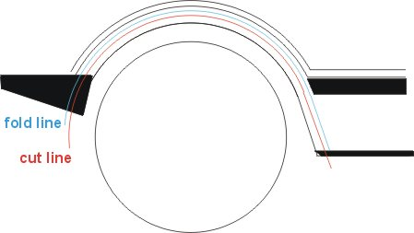  Fold and cut lines viewed from side | 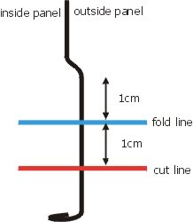  Fold and cut lines in profile form
To ensure a good job, its best to fully mark out 2 lines on the panel:
-The first line in blue is the line along which you want the panel to be folded at. This is the line where the wheel arch will end when viewed from the outside. Its not the line you'll be cutting.
-The second line in Red is the one which you cut the panel at.
Mark the lines out by hand using an overhead foil marker pen. Make a dot every couple of inches where you want the line to be, then go back adding more dots in between and then going over again time to create a smooth line joining all the dots. This allows you to make adjustments to the line as you go along while marking it.
Also mark the front plastic corner bumper following the fold line. Then remove it from the wing.

Cutting
For cutting, my personal choice is a set of hand nibblers. Hand nibblers are hard work, but as they only cut a few mm at a time, they prevent you from making a right mess of it should you go off coarse while cutting !
To begin with,use a hack saw to cut a line into the panel from the lip of the arch to the red cut line. Make these cuts about every 10cm all the way round the arch. This allows you to cut off the excess panel in 10cm sections making it more managable. Then use the nibblers to cut along the red cut line between each slit in the panel. When cutting, follow the curve you've already marked out - this removes any guess work.
Its much easier to cut a panel if the inside is clean and free from mud. The nibbler will tend to get clogged up and lose grip if its too dirty.
Once the whole line has been cut, finish off any immediate sharp edges with a file or rasp. The cut edge does not need to be perfect as you will be folding this inwards and the edge of it will not really be seen.
The very bottom plastic sill can easily be cut using a hacksaw. On a 4 door, there is a small bolt holding the trim to the wing. Make the cut just in front of this bolt.

Folding the panel
Folding the panel is where patience is required. You will not be able to fold the panel to a perfect right angle straight away. Take your time and only bend a small section a little at a time.
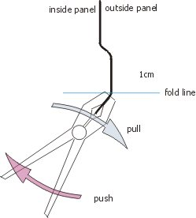 | Clamp your pliers or mole grips ( preffered as they grip better ) on the lip of the panel. The end nose of the pliers should rest on the fold line you have marked.  To fold the panel, pull the nose of the pliers outwards towards you while pushing the handle inwards and upwards. The pliers should pivot on the fold line. By pulling the nose out and down towards you, you are making the nose dig into the fold line and this help create a sharper edge. If using mole grips, place the fatter, rounder side on the inner side of the panel.  To begin with only bend the panel to about 30°. Repeat this every couple of cm all the way around. You should now start to see how the fold is progressing.  Once done, go back and repeat the process bending it a bit further. On the second bending, clamp the panel inbetween where you clamped it first time round. This makes sure that you creating a sharp fold line the whole way along.

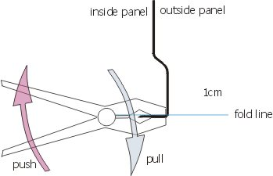 | Finally bend the panel round to 90°.  Depending on how well the panel has been bent, the fold line can be finished off by hammering along it to smooth out imperfections.  Tip: to preserve the sharp fold, place a chisel or something sharp on the inner side of the fold line where your hammering. This prevents the fold line being smoothed out too much.
Finally, for the front, you need to cut the corner bumper. You have already marked the fold line on this part but before cutting, place the part up against the newly trimmed arch and confirm that the line will match.
The part will easily cut with a large hacksaw.

