Here how one can strongly increase the reduction of a box of transfer
- One will benefit from the occasion for entirely restoring it.
- One will break up the article into 2 parts.
- The first relates to the manufacture of the pinions, the second the assembly of those and it is not inevitably simplest.
First part: Manufacture of the pinions

- Here basic materials:  - The joints spi, bearings and the small pocket of joints.  - That is to say approximately 300 euros at Lada.  - There is also most difficult to find, the pinions.  - In the solution put forward here, they will cost “only” 300 euros.  - Therefore, to give to nine and to reduce a box of transfer, it is necessary to leave on a budget 600 euros. | 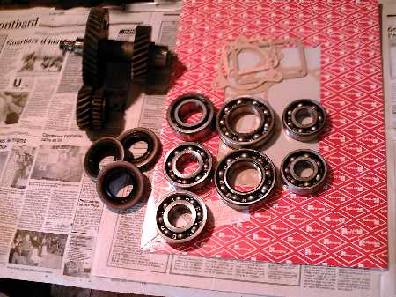
- In a box of transfer of Niva, the selection between “the large ones” and “the short ones” are done by means of a crown which blocks (solidarizes with the axis by the intermédiraire of a groove) either the wandering pinion long, or the wandering pinion of short.  - These two pinions being connected to them-even to another axis.  - This other axis actuating the differential.  - The principle is then simple on paper, it is necessary to reduce the wandering pinion of short and to increase in correspondence that which is on the intermediate axis.  - A chance for us, the differential is pulled by the pinion long.  - One then does not need to modify the differential.  - Here the pinion to be reduced. | 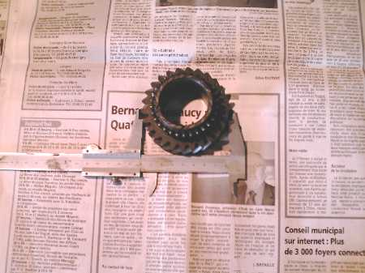
- And here the pinion once reduced.  - There is no magic in it, it is simply that I realized that the wandering pinion the 3rd speed of the gear box could make the deal.  - It has the same dimensions exactly.  - Its simple “defect” is that the grooves are reversed compared to the original. It will be further seen it is not finally a problem.  - To get it, it is enough to find an old gear box and to take it above. | 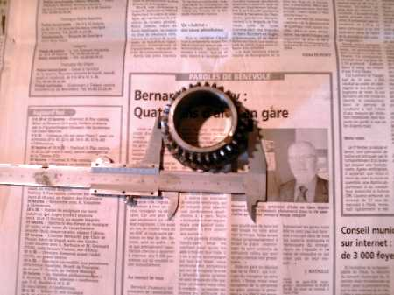
- Here the two pinions side by side.  - One notices the difference in diameter immediately.  - There is approximately 14 mm of variation.  - On the old one, the number of tooth is of 26, on the new one, 21. | 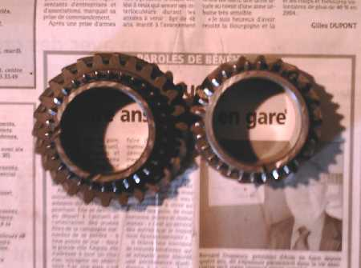
- Another sight of the two pinions.  - It will be noticed that the length of the teeth for the crown is larger in the new pinion.  - It is even better thus, the short ones will hold better, and will have less risk to jump.  - On the other hand, the grooves are less broad. I do not think that it is really a problem.  - Most important being that the dispatcher total is strictly identical to the old model. | 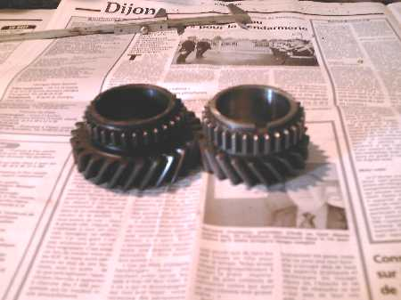
- Seen tree on which the new pinion goes.  - Here, with the new pinion. | 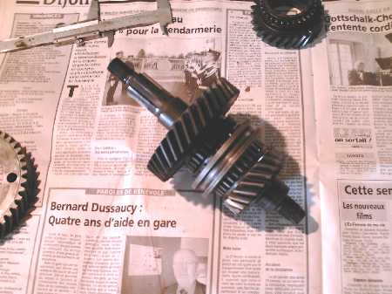
- Seen tree on which the new pinion goes.  - Here, with the old pinion. | 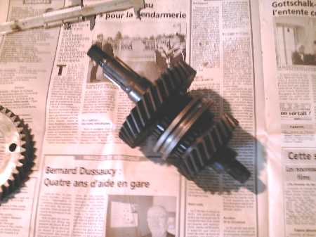
- Remain now the 2nd pinion to be modified.  - After seekhaving lengthily sought, I found that the crown of drive of the differential of the box of transfer had exactly the desired dimensions!  - Moreover, the canulures are reversed, Ca fall well, since those of the wandering pinion too.  - Here this crown, I recovered it on an old box of transfer, if not, they is approximately 70 euros at Lada.  - The old crown had 37 teeth, news 42. | 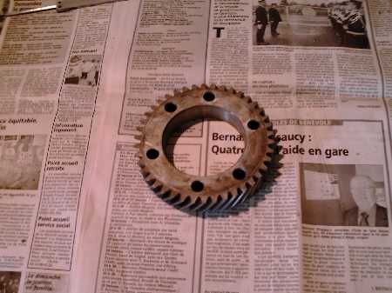
- The most difficult remainder to be made now, it is necessary to set up this crown on the contershaft.  - On the photograph, one sees the crown of the differential affixed against that which should be replaced. | 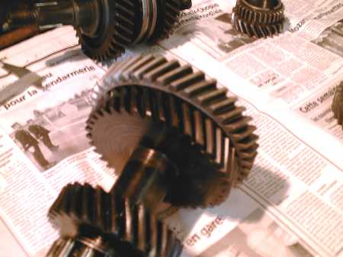
- It is thus necessary to find somebody to make the following job:  - To cut out with the wire by electro-abrasion the old crown.  - Indeed, this one, face-hardened, has a hardness of 199 kilos and it is out of the question of the “décémenter”, because then, the part would be foutue (or then, it would be a work even more complex, because it would be necessary to reprocess it and readjust it).  - The advantage of electro-abrasion, it is that she works cold and is not afraid of hard metals, on the contrary.  - Here the once removed crown of the tree intermédiare. | 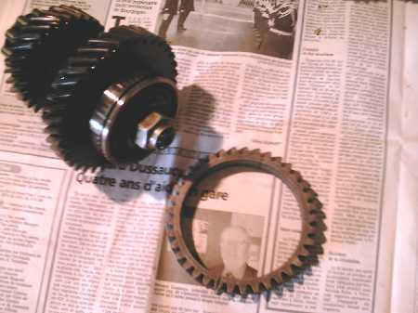
- As the pinion long prevents us from directly cutting out (obstruction) the crown with the good dimension, it is then necessary to ream this one to fix the crown of the differential inside.  - Attention, even if the pinions are only face-hardened (surface treatment), you need ceramics tools to make the job with the turn, if not, assured massacre.  - Once the fixed crown, it is necessary to crimp three pawns for the solidity of the unit.  - The cost of this work by a professional is approximately 300 euros. | 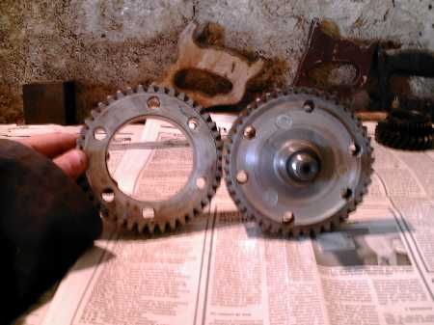
- And here is the result.  - A new contershaft, without welding, deformation and decementation. | 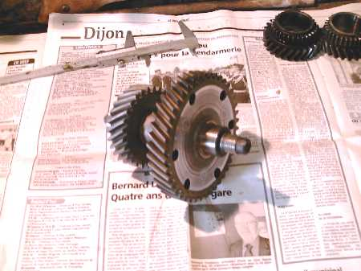
- The old one and the new tree side by side.  - One sees the difference in diameter clearly. | 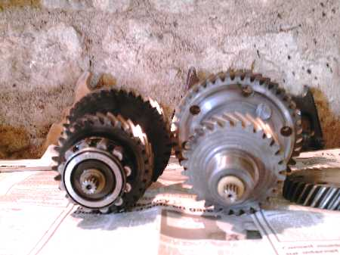
- Sight of the top. | 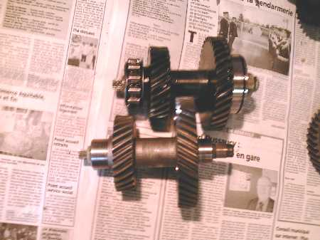

Large a thank you with Fabrice for this superb report and also to have divided it.

