CHANGING THE SEATS OF THE NIVA

Another news article of the Gorinel friend, where it illustrates the way to us in which it has changed the seats of his Niva. The “donor” has been a Fiat One. I hope that he serves to solve the doubts that lately have considered in the forum.
CHANGE OF SEATS
With this article I want to explain how I have made to change the seats to the Niva, first I visited several desgüaces and after seeing thousand seats, I was decided by of a Fiat One that aside from quite dirty, were practically new, and of step I also took two mirrors outer of a Seat Trans, that shortly I will place to him.
First that I have done has been to disassemble to the old woman seats with the base and everything (it is easier), once outside I separated the seat of the anchorage to the ground, and as it is possible to be observed in the photos, the base is not made level, I have made level because it with tube squared of 45mm of side and believe that they were 40 cm in length (I am not surely right now) but does not have problem, meter and it already is; as podeis to verify the holes is not done in center, so that the side that sees is to cloth with the support; the hole superior I have done, it of 6mm and I have put screws with flat head for screwdriver because of hexagonal head, it would graze in the guide from the seat when moving it, the inferior is of 8mm and I have put the same that the Niva in the guides brings.
Well as the width between the guides of the seats of Fiat is something smaller than the one of the Niva, I have placed a “U´s” of iron of 4mm (it exceeds with half of thickness, I went), doing to them you reduce in the ends so that they seat in the supports in both sides and a hole in each side of 6mm that agrees with that we have done before the same measurement.
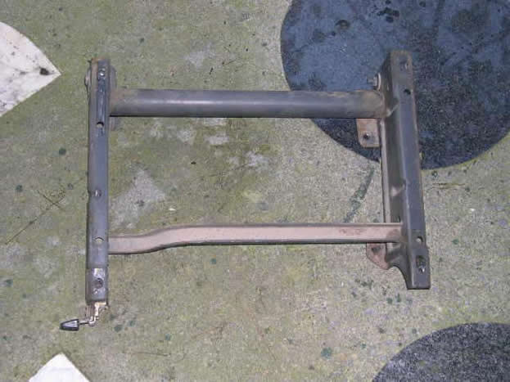
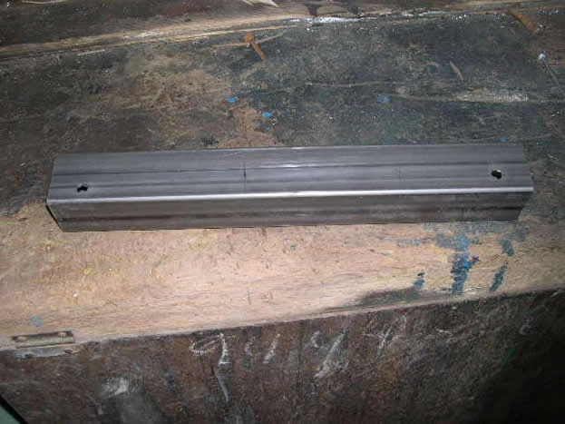
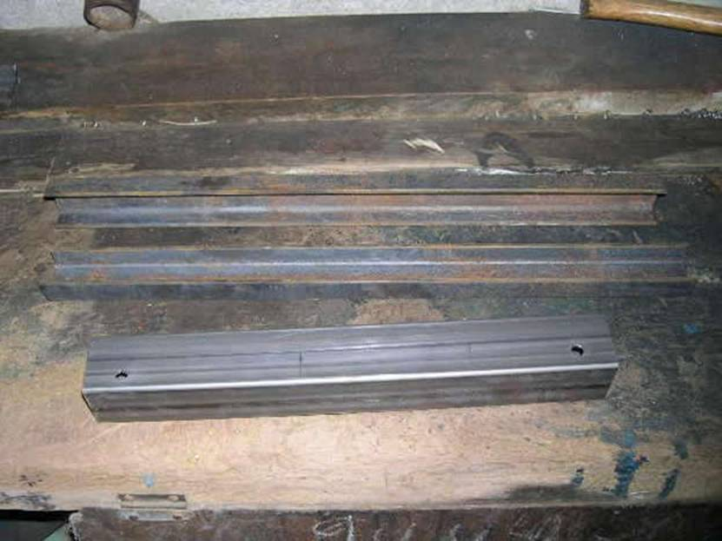
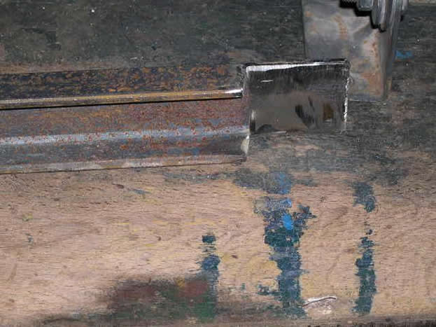
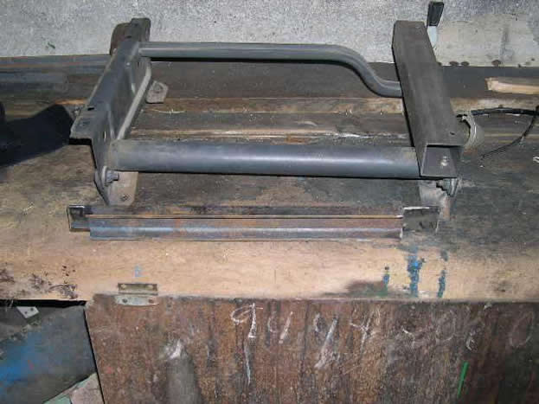
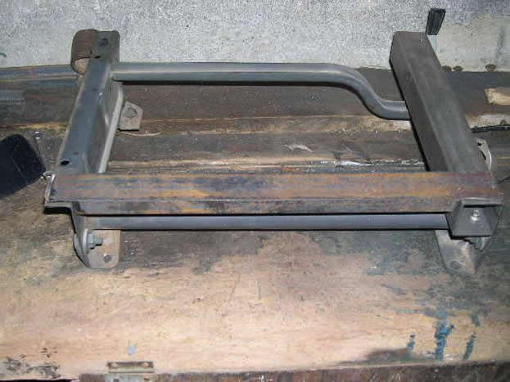
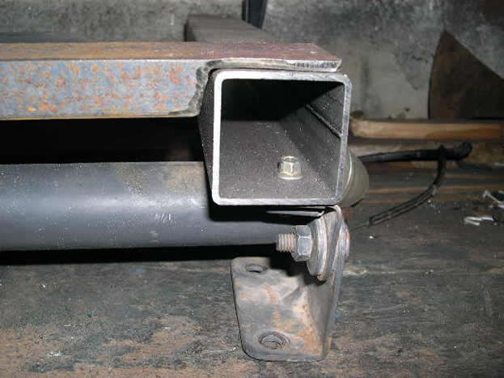
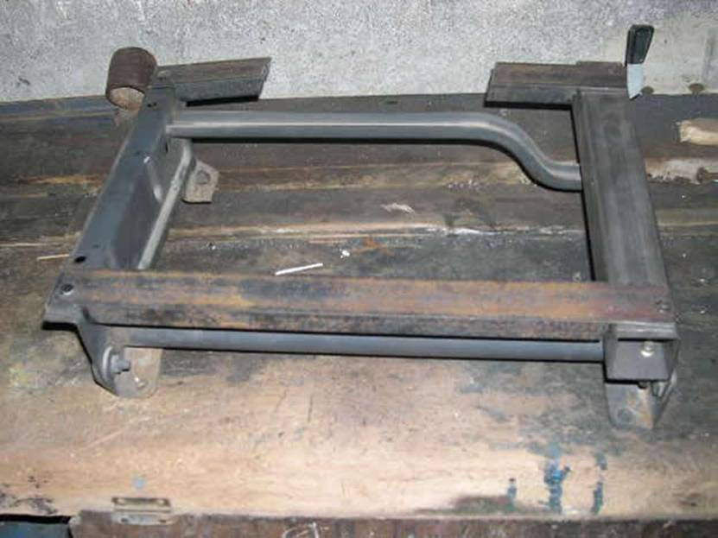
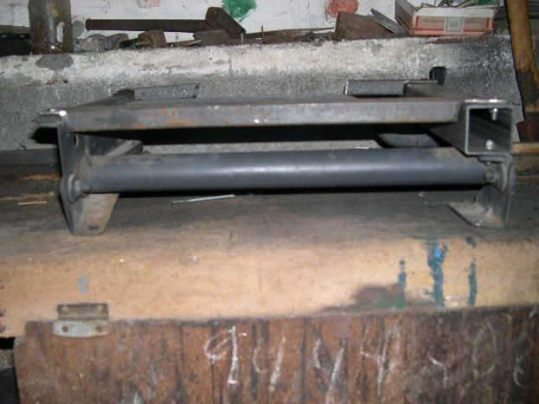
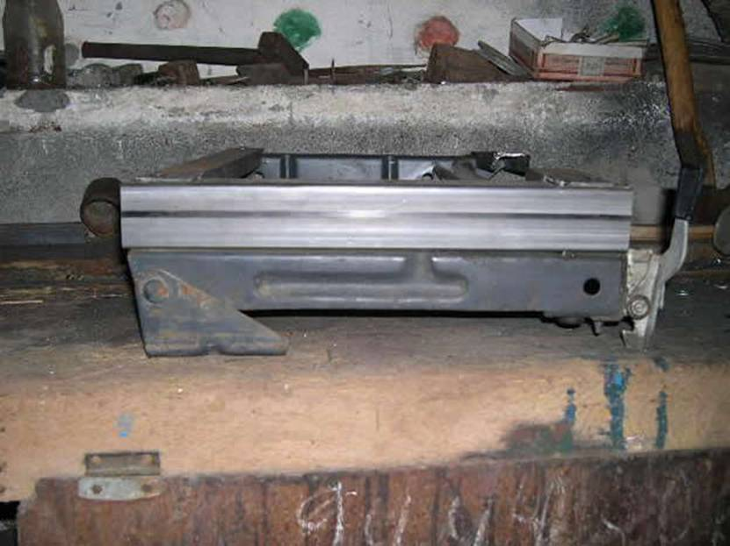

If you habeis determined to the photos, in the back part of the support of the seat, the “U” is cut, that is because the seat has a convex form underneath, and of thus not doing it, it would beat forwards when moving it (also it would be possible to be done doubling the “U”, and giving the form him of the seat, but he is very complicated).

The following thing is simpler, only is to take the seat, to give the return him and to present/display all the frame that we have done on the guides, to mark the holes of the guides, to drill and to place the attachment screws (preferably with flat head). It will be a thing thus.

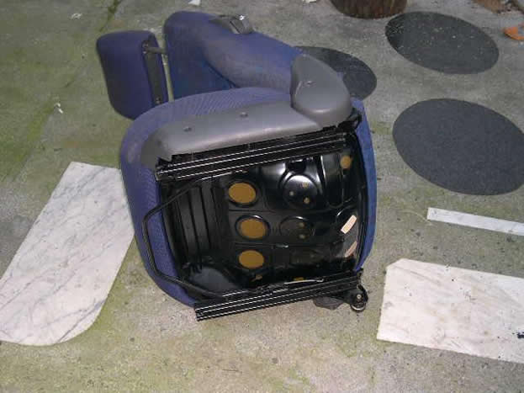
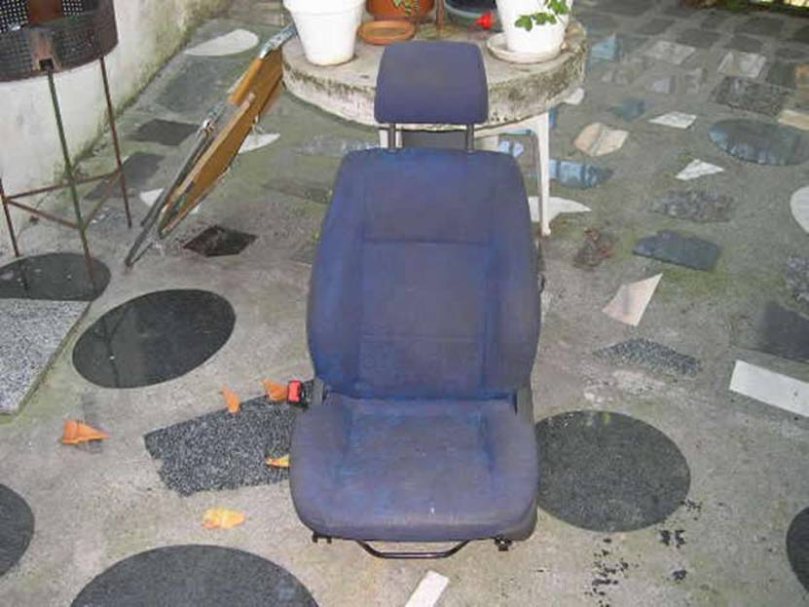
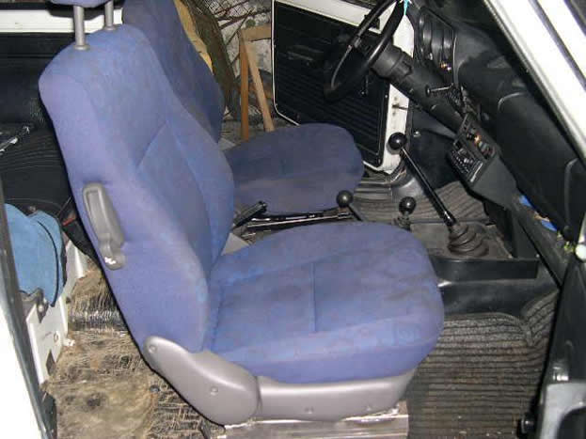
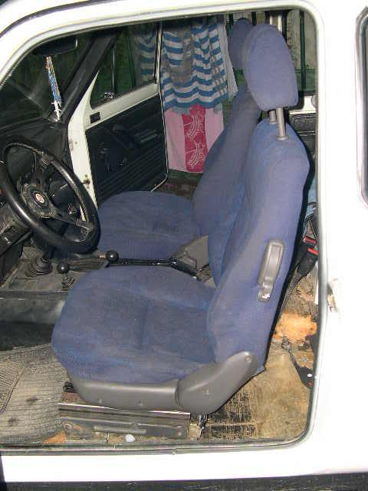

Good, seem I have left rather well; now only lack a very good ready cleaning and; if you habeis determined the insulator that covers the ground is made dust, that for the month that comes. I hope that this article has been used to you for something, and already sabeis, if I can ayudaros in something I will be enchanted to do it. A greeting.
Until the next one.
22/09/2005
Alfonso
____________________

Some images I’ve collected:
This piece of 40x27 box-section (41.5cm long) is the key to making the Niva’s seat mounts level, and thus being able to fit seats of similar width.

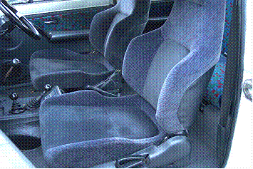
Honda Prelude seats

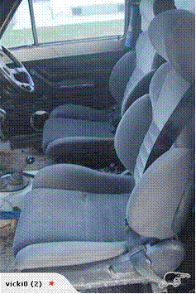
Toyota Celica seats

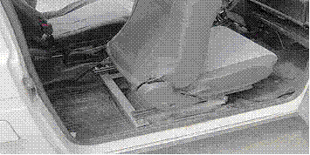
Unknown

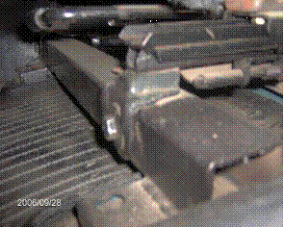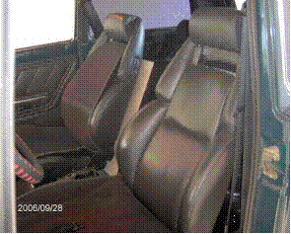
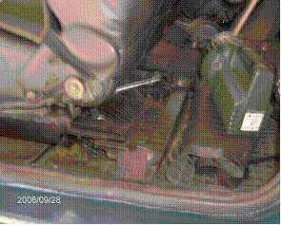
Unknown

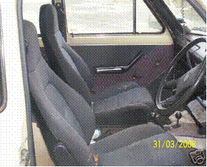
Mazda MX-5 seats

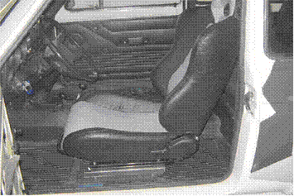
Unknown

