Lada Niva
Welcome to "NIVA NUTS"
My name is Robin and with my wife Wendy we both share the passion of owning a Lada Niva and below is how it looked in 1992 when first purchased.
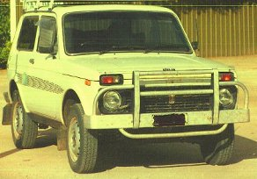
After researching the Lada Niva, its body style, mechanical superiority, superb handling, charisma and 4x4 simplicity when they first arrived in Australia in the early 80's, it was decided I must have one some day. Ownership occurred in November 1992 when I bought a standard white 1989 Niva (which had 114,000 kilometres on the odometer), from a second hand car dealer who didn't know a thing about the vehicle, other than it could make him money at sale time. On the other hand I knew what I wanted after looking at 6 or more other Nivas over the past month, so pounced on the bargain.
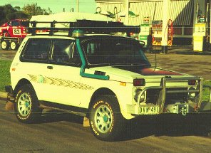
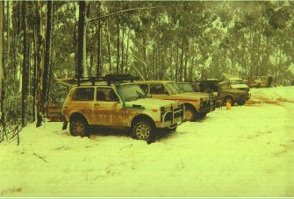
This is how our Niva looked in 1994, it has undergone many changes as we like to be innovative, maximize the Niva attributes and just like tinkering. It is not possible to include a detailed list of instructions for the modifications or improvements that have been completed, so have a look anyway. I will be able to E-mail some info with JPEGS on specific items in the near future as we record them on disk.
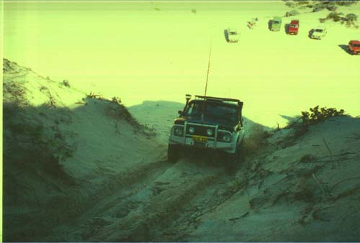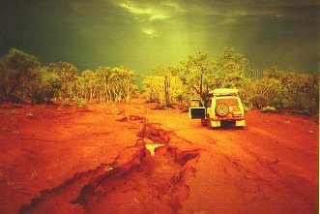
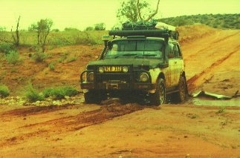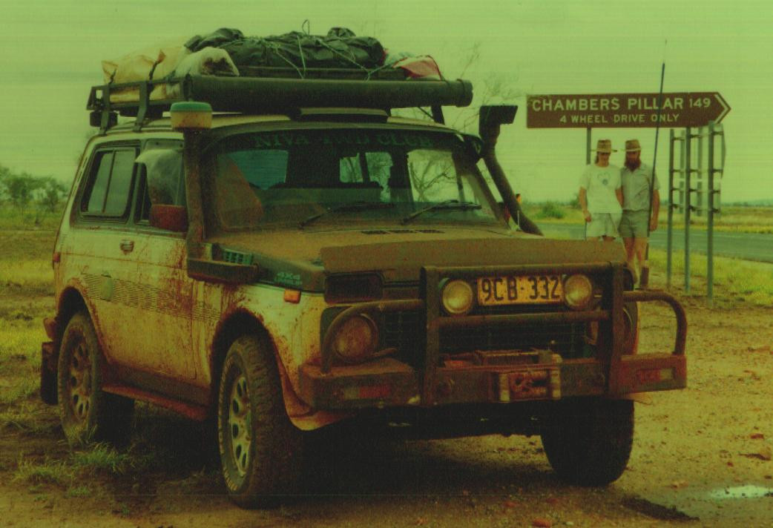
By 1998, another face lift and more personal improvements.
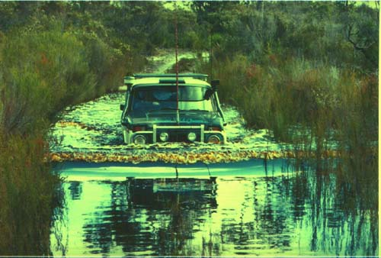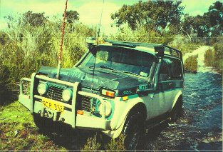
Doesn't look deep, but the water was over the headlights. On an another part of this track the water was over the
bonnet a couple of times with a bow wave half way up the windscreen. Location is 3 hours south from Perth W.A.

10 months to rebuild our NIVA after fire damage.
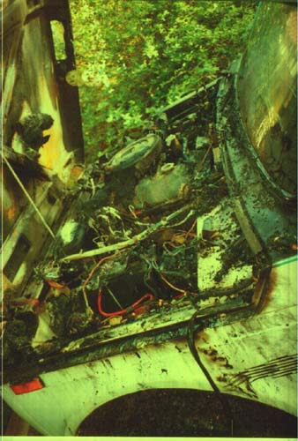
Late one night in May 1994, an after market electrical solenoid short circuit caused a fire in the engine bay that severely damaged everything forward from the dash and windscreen to the front bar. Thankfully only the top half of the engine suffered external damage. The fire brigade arrived to put out the fire and liberally hose down the interior and engine compartment.
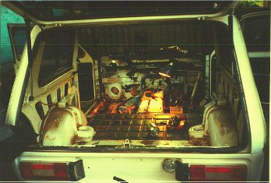
Over the next 10 months of rebuilding, the body was progressively gutted and stripped of all running gear, suspension, engine, interior, electricals, glass; yes everything in total. Where required metalwork was done, repainting, reglazing, complete new interior, custom wiring loom and other modifications to further enhance the Niva legend.
It was timely to put new bearings in the transfer box and to fit a complete new clutch kit. The engine and gearbox were left untouched when removed, as both were still running very strong at 160,000 km. Thank goodness !
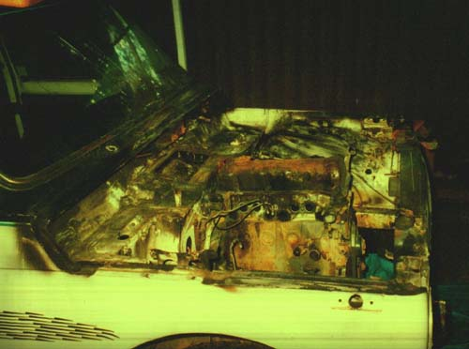
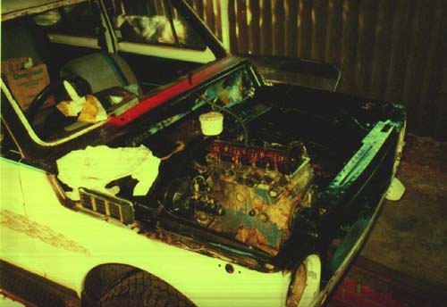
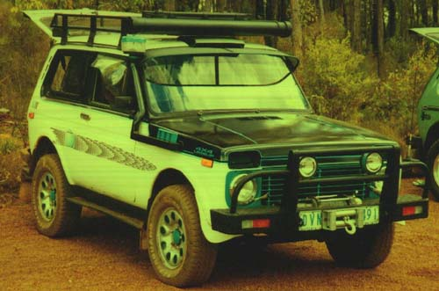
cleaning up under repair on the road

Some of our Niva's extras.
dual battery system with a Rotronics 100 amp isolator
85 amp Bosch Alternator BXU1285
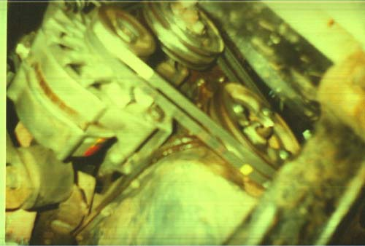
1 air horns
custom built wiring loom which includes: 4 circuit breakers, 44 fuses, 30 relays, 8 interior lights, custom built dash assembly
air compressor - Thomas
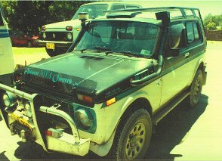
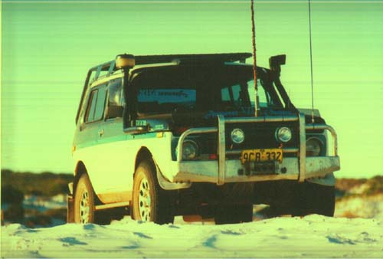
another upgrade and more improvements 1997

Our Niva has more than meets the eye.
Other modifications include two snorkels, the left side for ducted fresh air through the heater intake and the right for carburettor fresh air. See above pics.
The electric's have been waterproofed to enable deep water crossing, i.e. over the bonnet..
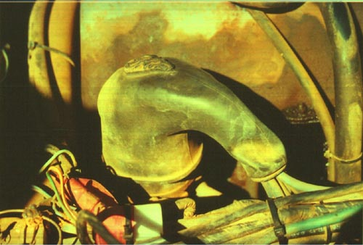
Three thematic fans - 350 mm x 1 & 250 mm x 2 (added for cool running on days of extremely high temperatures, particularly when crawling in low range for long periods). Larger cooling system capacity.
Roof rack, new paint trim.
Raised suspension, reinforced lower front control arms, reinforced rear axle housing, dual rear upper trailing arms and strengthened lower rear trailing arms.
Rear disc brake assembly.
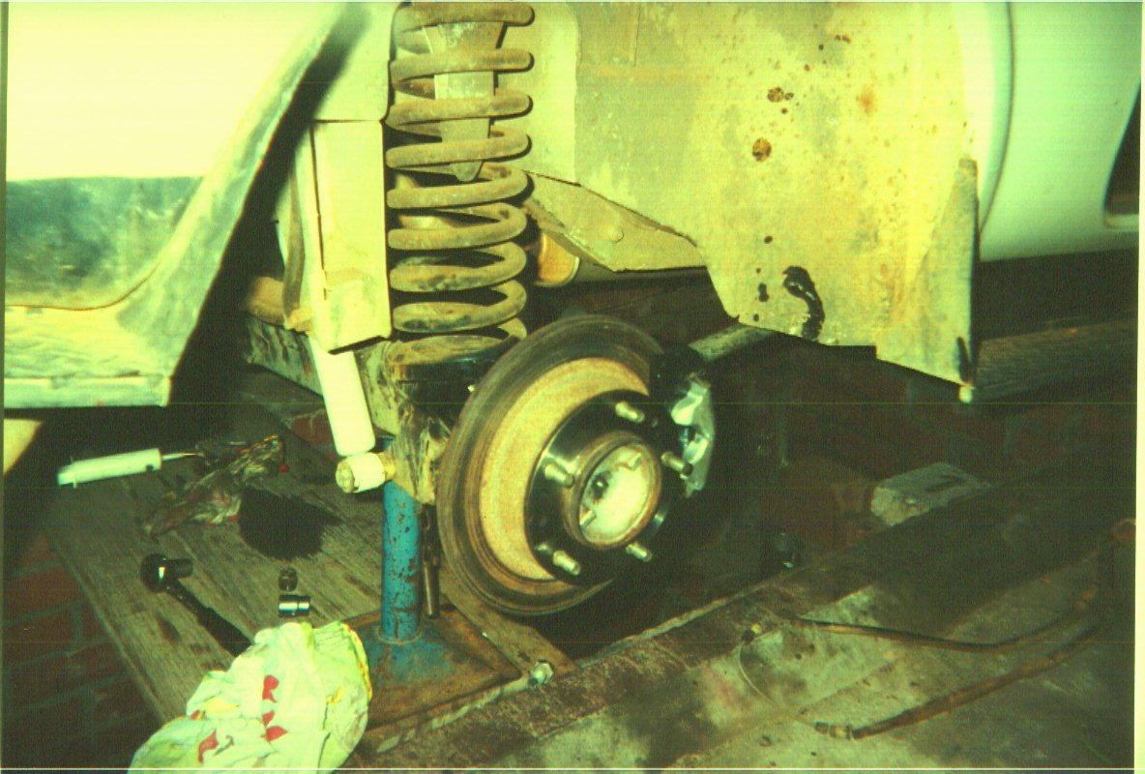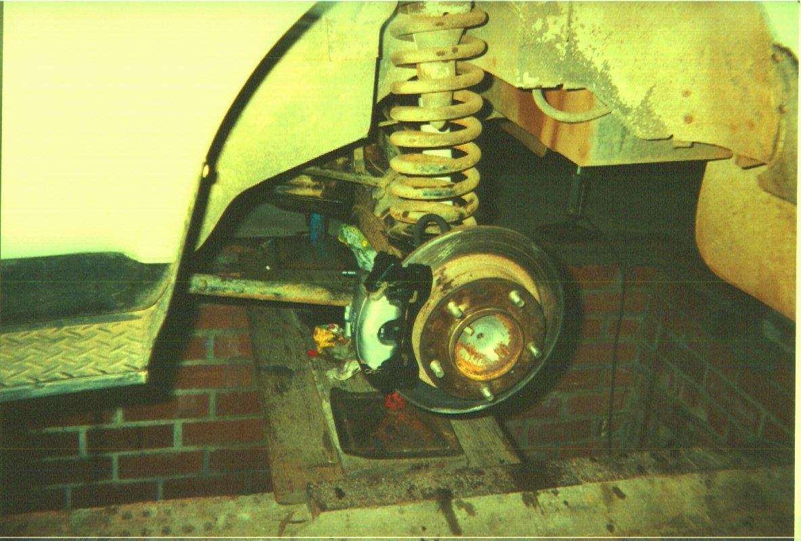
Tyres (Dunlop Adventurer 215R 15)
Sports camshaft.
Weber jetted for 1600 cc GT performance with reasonable economy.
Performance sprocket timing chain tensioner. (borrowed jpeg)
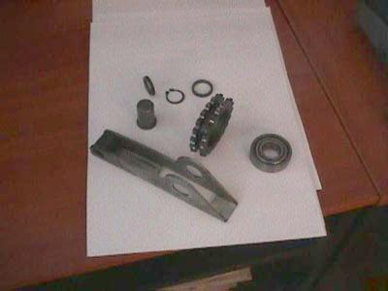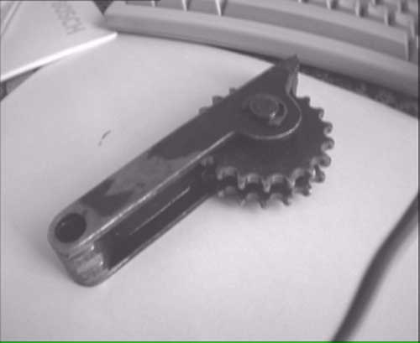
RFDS HF transceiver, 27 meg hz CB.
New grill and headlight surrounds.
Power steering (Toyota Cressida), Fiat 131 steering column.
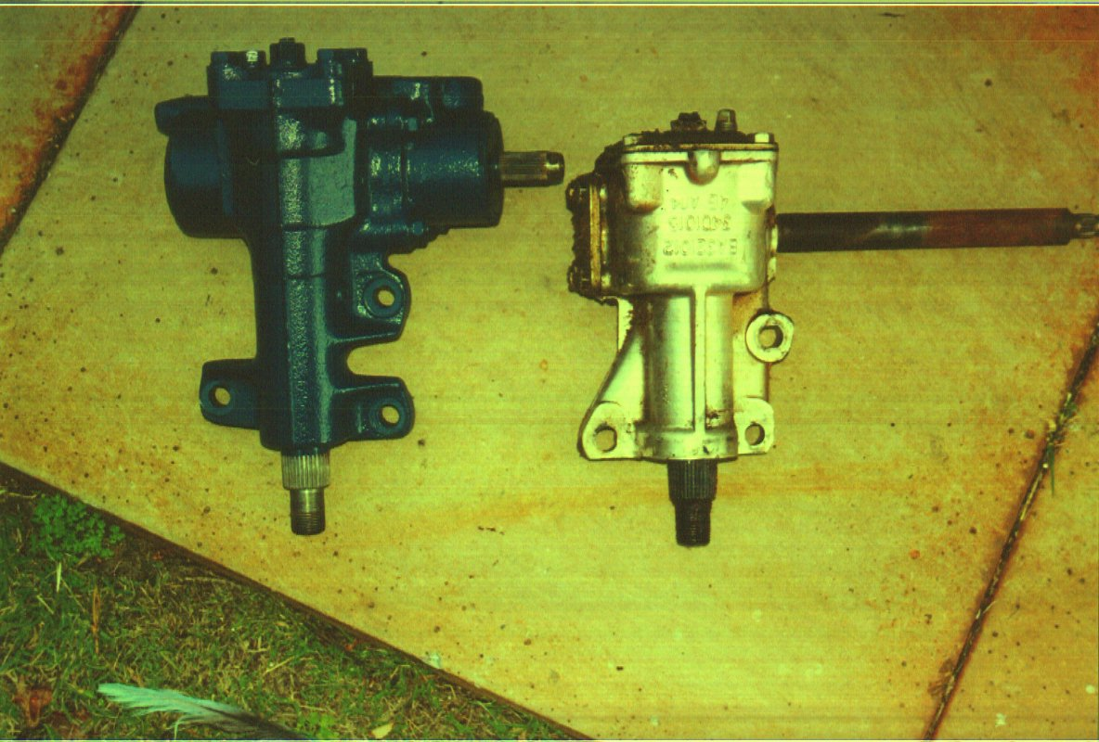
Limited slip differentials in front and rear.
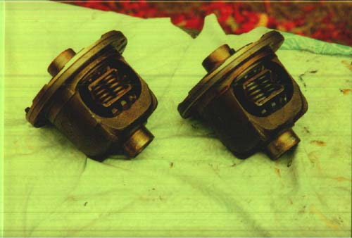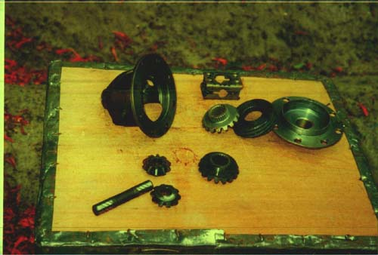
100 litre fuel tank made for the inside cell area and can still utilize the rear seat for passengers and 45 litre tank under rear of body, swing-away spare wheel & petrol can holder. We now carry 165 litres of fuel.
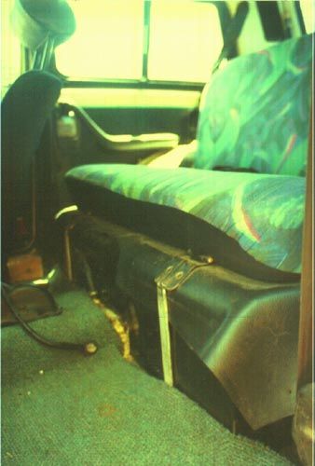
Warn 6000lb electric winch.
The engine has never been pulled down, the head has never been off and the sump never opened and the Niva has just clocked up 205,000 kilometres, plus still able to cruise at 120 kph.
One of my many projects I am slowly working on is to rebuild a recently acquired 1700 cc Niva engine.
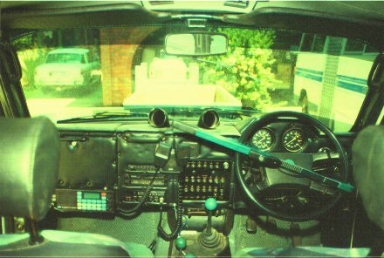 Interior of our Niva.
Contact us for more information and pictures wenro@iinet.net.au

