Lada with multipoint injection
(Author: Török Imre (Imy), last revised: 2007-02-12)
Article is translated by z.
The injection system consists of simple parts like:
- fuel pump (in-tank system of some Opel, Audi, VW or alike)
- Air Volume Sensor (Seat Ibiza 1.2, according to its Bosch No.)
- Control Unit (Opel Ascona 1.8, according to its Bosch No.)
- 4 injector valves together with inlet manifold (custom design)
- Throttle valve of 70mm. Possibly from a BMW
- Water temperature sensor (many models would fit)
- Adjustable resistor to modify the water temp sensor's signal
- 2 x 6..7m of fuel pipe, for the main pipe and for the return pipe
- wires, one relay, two fuses
- much enthusiasm
I had to modify the hole at the fuel tank (where the level sensor is), because the fuel pump clamp could not be put in. The whole tank modification took half an hour . I replaced all fuel lines on my car. It was much dirty inside, fuel could hardly pumped through it.
I removed the carburettor and the inlet manifold. The custom inlet manifold + injector assembly could fit bolt-on. Please note that my battery had been already moved to the left side of the engine bay, in the place of the windscreen washer reservoir. Therefore the battery was not an obstacle. I also removed the battery mount.
I mounted the air volume sensor onto a bent aluminum plate. It is installed on the inner wing. The volume sensor and the throttle valve are connected with a FWD car's front halfshaft-joint rubber housing. (Possibly a Wartburg one). It can be a steering rack rubber housing either. I don't know what is it exactly.
The ECU (control unit) is located at the bottom plastic shield of the glovebox (in the cockpit). For the cables I drilled two holes on the bulkhead. This way I could keep the cable length the shortest possible.
The throttle pedal had to be modified, it is now cable operated. As seen on the pictures below, it can easily be fine-adjusted by hands.
Experiences for the first time:
After installation it started for the 3rd or 4th try. It functioned OK. There had been only a few slight problems, which were solved in the week after.
One of these probelms was that the engine took too high revs for the slightest throttle movement. You could not start the car moving in a moderate manner :-). This was caused by the air volume sensor: the resistor surface inside the assembly was worn out. I moved it into a position where the resistor surface was OK. After applying some tricks it worked OK.
An other problem was very-very wrong emission results at all revs! Few thousands of HC, much above the instrument's limits. After some Internet research I came to the solution of modifying the volume sensor resistance. After setting this, I produced 0.15 of CO and 150 of CH, and almost an exact 1,00 of Lambda. Unfortunately at idle speed it is still not perfect, however its very much better than before. As I investigated, the 70mm throttle body was produced with big gaps. These gaps dont matter at a huge 2500-3500ccm engine (for which the throttle body is originally designed), but it really counts at such a small engine like mine. The future solution would be a 1.4 Opel throttle body. This one has a diameter of 35-40mm, which seems to be OK for my displacement.
Practical experiences:
it never misfires. It accelerates dynamically from the lowest RPM. Since I connected the choke system (electronically) it starts for the very first turn even in minus 14C. (I dont have to pump the accelerator before starting now). With the potentiometer I can vary the mixture from the cockpit. After starting the engine, and pushing the accelerator 3-4 times, I can see the dark smoke in the rearview. This means I can immediately weaken the mixture. Its consumption is 9-9.5 litres pro 100km in the coldest Hungarian winter, in city traffic. I tell you I really push it to the metal.
On the other hand throttle response is a bit delayed. I assume this is for the huge distance (60-80cm) between the throttle valve and the air volume sensor. Therefore I dont have that particular feeling of quick throttle push and its instant reaction from the muffler...
It really has a big advantage, which could be told after the very first try of the system: engine is not shocking even at idle! This is caused by the even length of intake pipes. At factory setup cyl.1. and cyl.4. have long inlet pipe, while cyl2 and cyl.3. have short pipes. This means the central and front/rear cylinder pairs get different mixture. I can cruise at a speed of 90kph while my internal rearview is not shocking at all. A very distinctive shocking is now eliminated. I did not even dare to say it was because of the inlet manyfold assymetry - but it really was!
Comparison:
At the company I use an Opel Corsa 1.4i one-point injector car. It easily consumes 8 litres, while the Lada eats 9. But the acceleration of the Opel cannot be compared to the Lada. The Opel gives normal heating after 20km, while the Lada does it after 200m.
Well, this is all I can say about the thing.
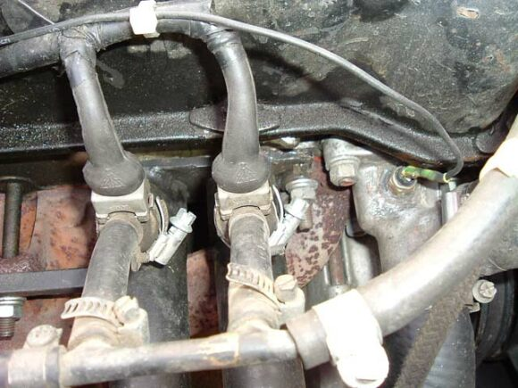
Fuel valves. Temperature sensor welded into the cast alloy
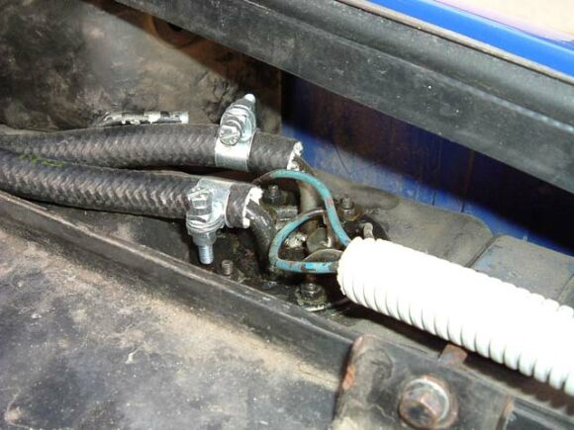
Conncection of return pipe at fuel tank
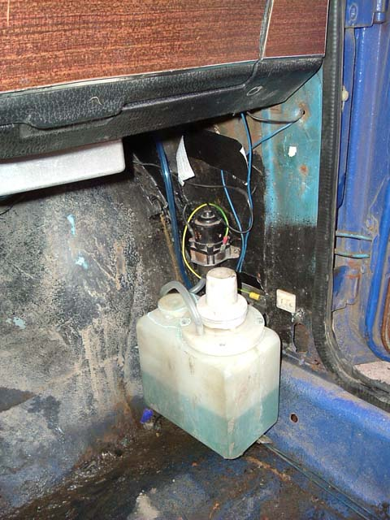
Temporary place for the washer reservoir.
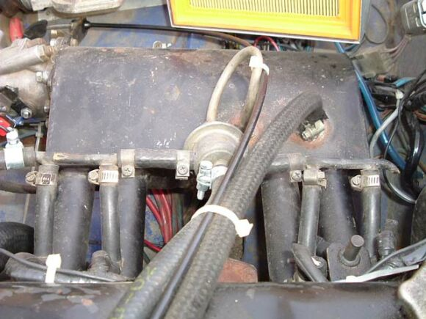
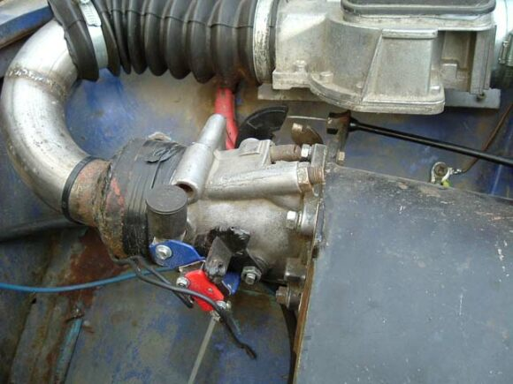
Throttle body
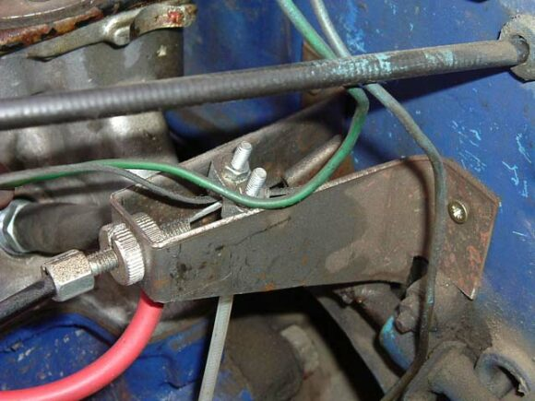
Wire operated throttle + fine setting possibility
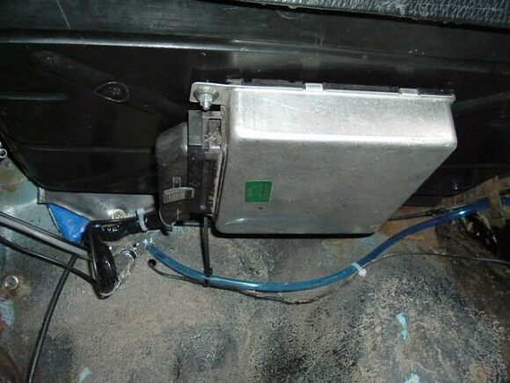
ECU

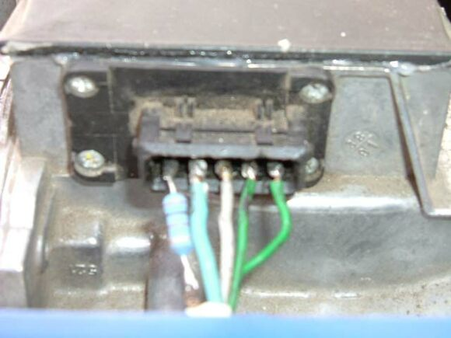
Resistor at ECU connection
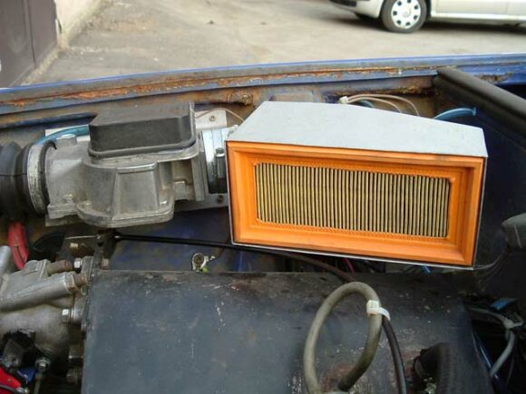
Air volume sensor and custom airbox
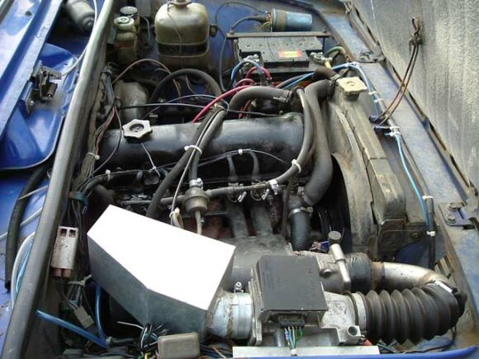
This is it...

