Detailed History of the Development of the Niva
Ivan Shevelenko
In the summer of 1970, the chairman of the council of ministers Kosygin arrived at VAZ to look where it has been buried millions and millions money. Satisfied with the done work of companions of builders, it has met designers of VAZ, and has stated them thought, on necessity of the comfortable car for a countryside.
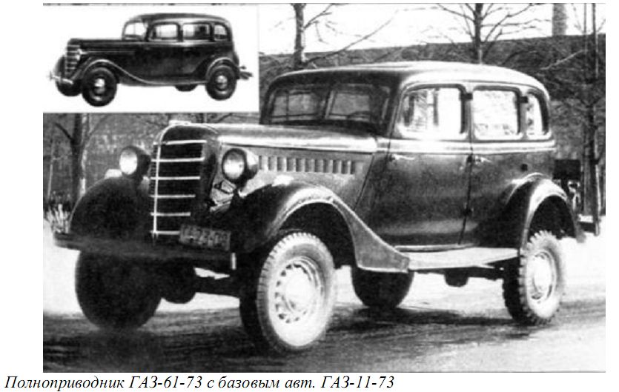
As a matter of fact is became the beginning project 2121. Because in 1970 VAZ worked with FIAT, there were thoughts for usage in production FIAT "Kompanolu", witch was issued in Italy, and was in usage at the Italian gendarmerie and military. But the car was morally and technically become outdated. Also there were requirements all the same on contemporary manufacture to start the modern technics. Therefore the project was rejected. Besides the important role was played by the factor — to use maximum quantity mechanisms from serial 2101.
Thus there were two ways of the decision — to build from zero or simply to palm off under "2101" one more axle. As a matter of fact, the second variant was known the Soviet industry: from GAZ–11 has been made GAZ–61, of the Moskvich 402 — 410, from the GAZ-20 "Pobeda" — GAZ–72. But cars were poorly passed because of long body overhangs and high probability overturning because of the high centre of weights.
PIC: All-wheel-drive-vehicle GAZ-61-73 with original GAZ-11-73
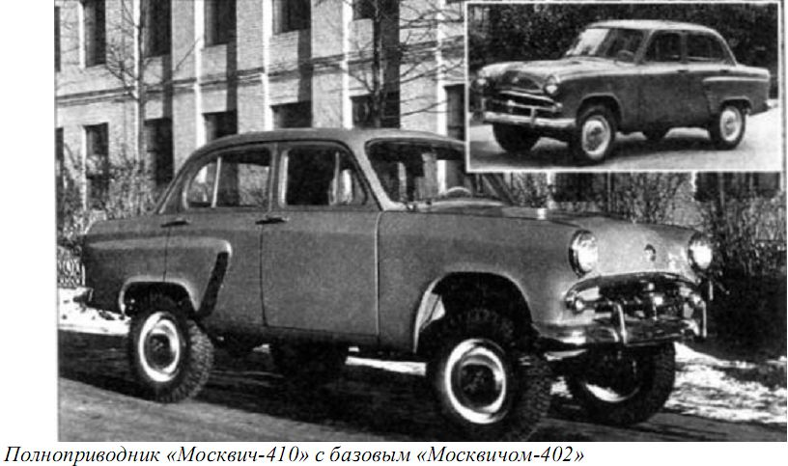
PIC: All-wheel-drive-vehicle Moskvich-410 with original Moskvich-402
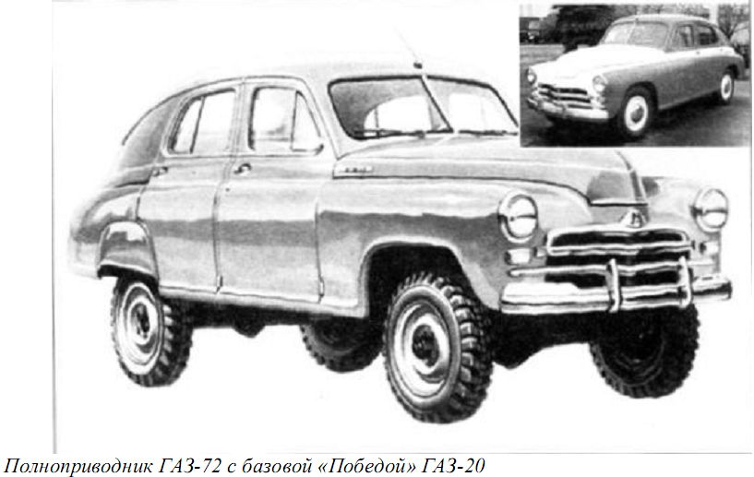
PIC: All-wheel-drive-vehicle GAZ-72 with original GAZ-20 “Pobeda”
So, having experience of a headache of the "lifted" cars, have decided to do the car from zero. And the first works went without designers. But only constructors. They tried and result of they work — E2121.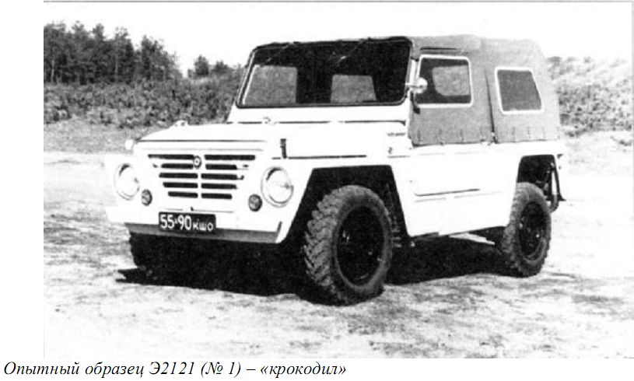
From a technical aspect it has been made that: the engine in volume 1.6 litres, attached a standard gearbox with an altered rear section, to it unique transfer case, and a reducer of the front axle fastened rigidly to the engine. Thus — front axle and transfer box incorporated shaft, instead of cardan (CV) shaft. As the forward suspension bracket was independent, and driveshaft yet were not — was used a two-thorn, in a consequence replaced on three-thorn. The back was as at Classical Lada 2101. Feature of transfer case was 5 modes: Front axle, Back axle, the full drive, a full drive with lower row, a neutral. Diff in transfer box was not. However, if to trust words of designers, on VAZ there would be another the equipment for gear wheels — this transfer case could be in a serial car. But alas. And knots 2101 died as flies, therefore the all-wheel drive version has gone to a series.
PIC: Experimental car E2121 (#1) – “Crocodile”

That would not arise at people of superfluous questions — the car was called by "Formika", and have pretended to be Romanians.
Even logos have thought up:
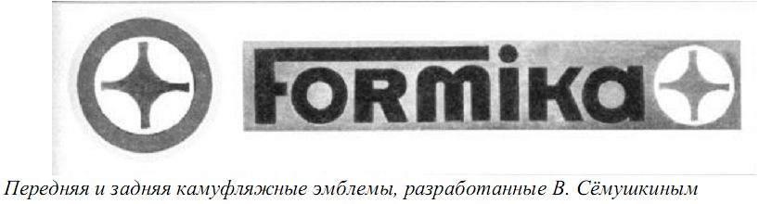
In total it has been made two copies E2121. Green and white. One passed tests for endurance — over another did experiences.
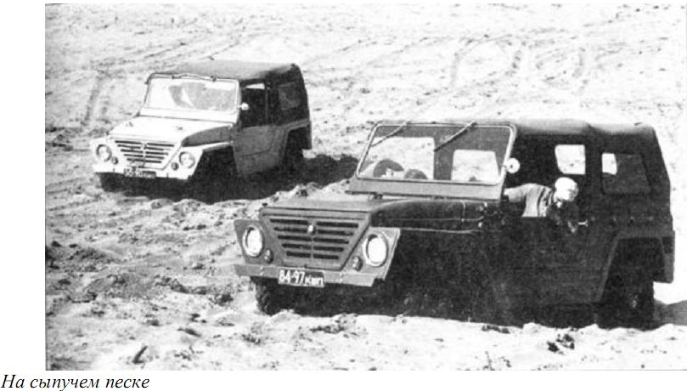
PIC: at the sand
When has arisen engeeners and designers were played, made experiments and compared E2121 to GAZ CARS and UAZ, in work Valery Syomushkin was connected. The continuous designer of the NIVA.
To work over it it has begun still the student when wrote degree work "the countryside Car". As result — to it there was a task in view — to make design of the car, for a countryside. But beautiful, stylish and elegant. That passableness would be also women easily gave (I exaggerate:)).
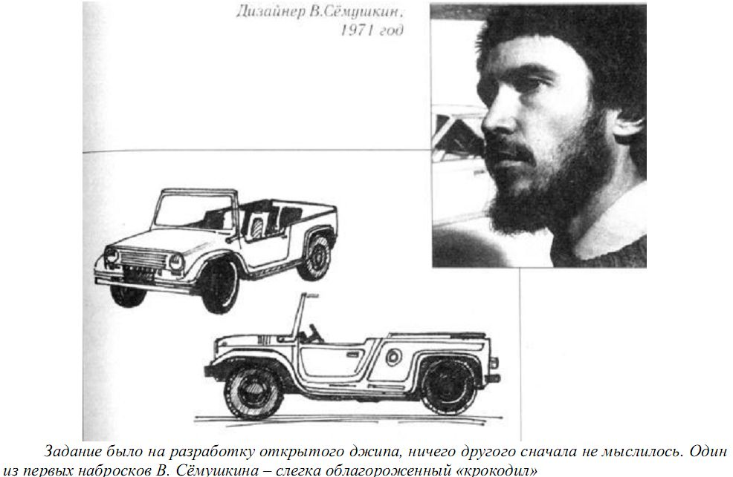
PIC: Syomushkin V. and his first picture of new car.
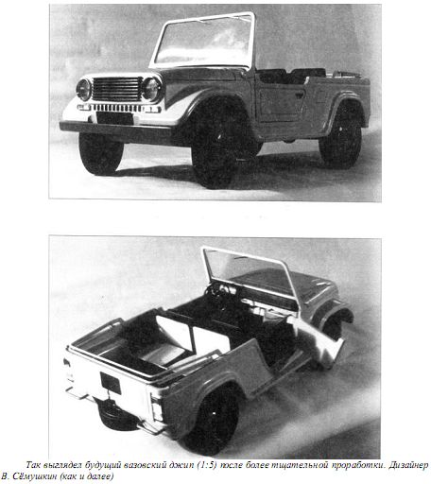
Creative attempts of companion Syomushkina:
PIC: Model 1:5 of new design.
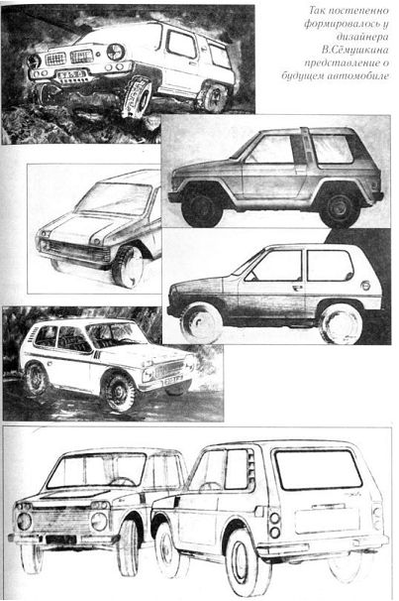
PIC: Pics by Syomushkin

As result — a breadboard model of the new car:
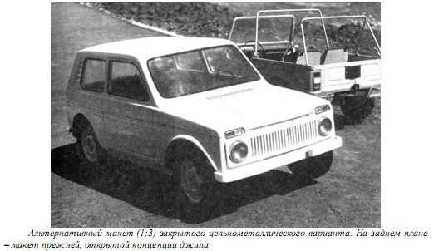
PIC: Model 1:3 of car with closed cabine and open (cabrio).

By the way, in a breadboard model the spare wheel under a cowl has been placed. And as it appears — spare wheel it is a burden for the constructor. Then with a field 2123 with it too rushed without knowing where to stick. So, nobody thought of safety, it was necessary it somewhere to place.
To brakes then claims too have begun — if on E2121 forward brakes were drum-type then on 2E2121 they did not cope with loading. Also it was necessary to make brake disk. It was necessary to invent "floating" bracket.

So, after different technical councils, the commissions, abuse — the car have started in pilot production — to make 4 pieces. But somebody from above, has ordered not to touch manual box. To persuade it has not turned out, and make separate transfer case. There alterations that was — longer shaft and other back cover. So is not present. On today descendants disentangle that great decision. Besides, on experimental cars have decided to do a constant full drive. It was necessary to lower load on transmission. Thus it has turned out nowadays existing transfer case.
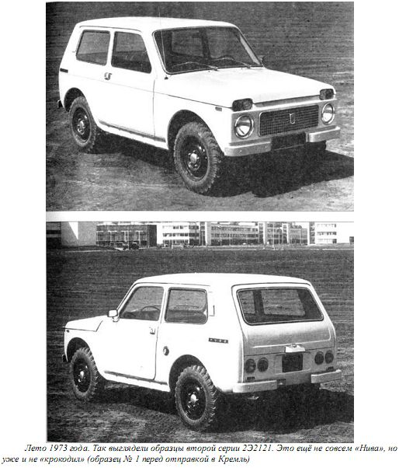
PIC: summer 1973. It’s a second models - 2E2121. It is not a “Niva” but and not a “crocodile”. This is a 1th ex. Which transfer to a Kremlin.
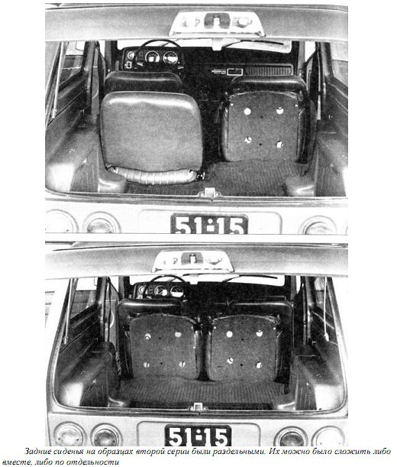
PIC: Salon modifications of 2E2121. It was in technical task.
On colours four samples were divided so: №1 — lemon-yellow. Has left to the Kremlin. №2 — cherry. Experiences on reliability. №3 — mustard. Laboratory researches. №4 — white. Too reliability. And on number two — drive in distant run across Central Asia. On purpose to learn that it for the car. As group support there has gone the UAZ-469. In the course of driving across Central Asia — the muzzle has started to collapse. Have hardly made, and have gone further. In the same place it became clear that at 40 degrees of environment, on sand, the car overheats. But it have given up as a bad job, and fix a current here recently electrofan installation. So, have driven then on a skilled copy nicely — both sand, and Pamir. Have returned on factory, have studied, and have sent with "white" on experiences.
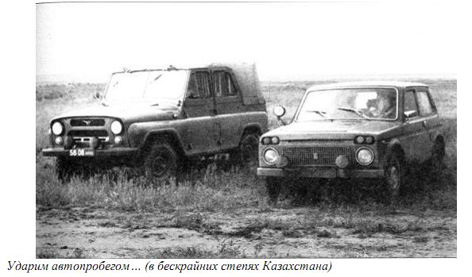
PIC: At the Kazakhstan. Experimental ride.
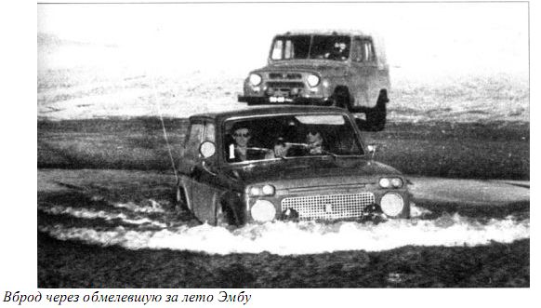
PIC: Fording the Emba river.
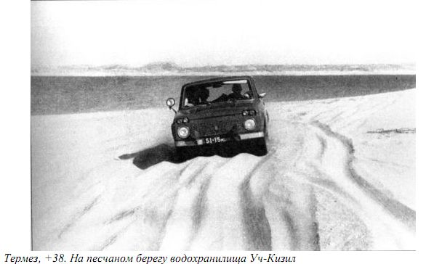
PIC: The Termez, +38 at sand bank of storage pool Uch-Kizil.
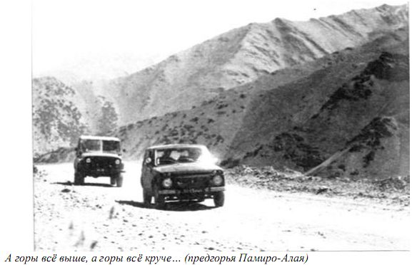
PIC: Mountains is higher and higher, Foothills of Pamir.
In experiences on passableness — it was studied absolute all. Up to the form of a beam of the forward bridge. And not car "evacuation" was the unimportant factor. Then winch was not — there was only a tractor and crowd of good fellows. In comparative arrivals — 2E2121 lost UAZ. But only in places — where a role played clearance. In the rest — even it was better, at the expense of smaller weight and the best weight. By the way 4й the sample — was broken. Burst rear driveshaft has caused car revolution on a dirt road.
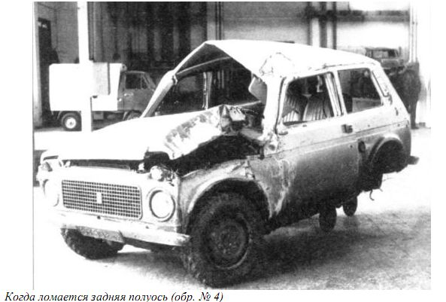
PIC: Destroyed car after broken rear driveshaft.

By the way, the tachometer with 2E2121 has for ever registered in the panel of devices. It as aim to secure the engine from "overturn".

So, in January, 1974 two other updating have let out: 3E2121. Plus one more in October. The presented samples differed from 2E2121 optics, a body, an interior. It was field almost habitual to us.
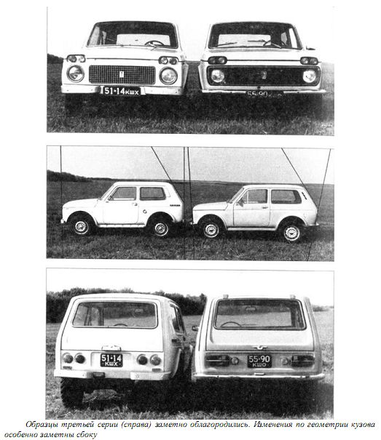
PIC: changes between 2nd and 3rd series. Changes at body most viewed from side.

And as a matter of fact, the state quality control of the car which lasted about half a year has begun.
On a state quality control take part a following cars: Izh–14, Luaz-969, UAZ–469B, LandRover 88, Range Rover.
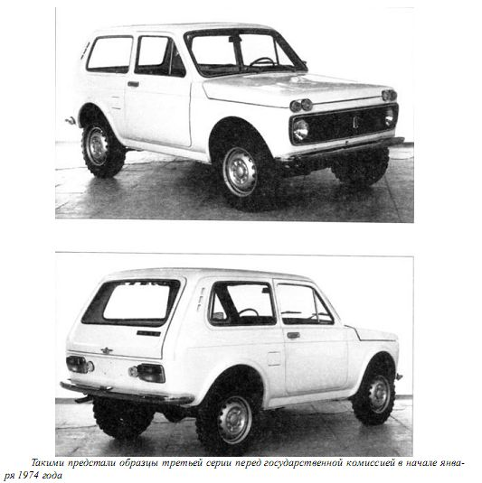
PIC: 3rd series for government examination
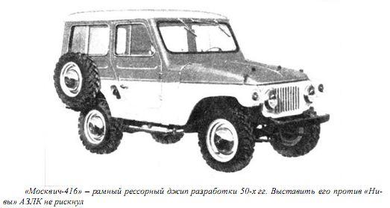
PIC: Moskvich-416 – offroad car with leaf springs. It’s a ’50 car. To expose it against a NIVA, AZLK (factory, where construct Moskvich) has not dared
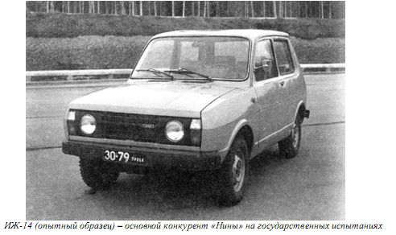
PIC: Izh-14 (experimental model) – main competitor of Niva.

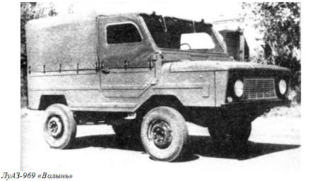
PIC: LUAZ-969 “Volin”

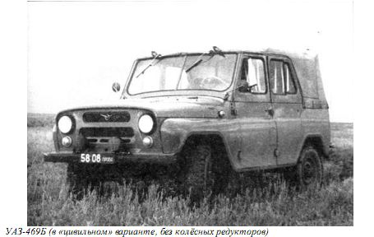
PIC: Uaz-469B (citizen variant, without wheel’s reductor)
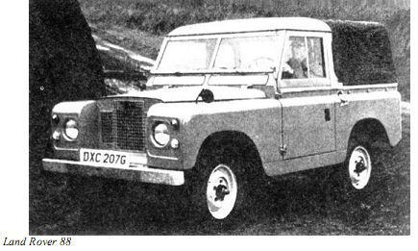
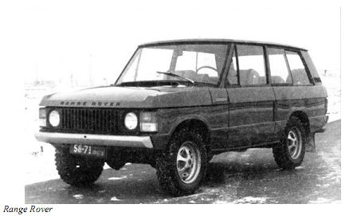
Whether it is long short, but 3E2121 went well. Often leaving competitors behind, for the account of "dynamic passage of obstacles". It was opening for the others peoples. They also could not imagine that so it is possible to pass dirt.
Tests for run have then begun. Long and tiresomely went on the country (USSR), from the North, on the South.
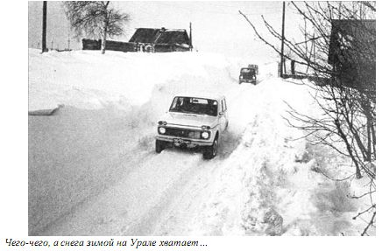
PIC: Snow in Ural (Central Part of USSR, now Russia)
PIC: Moskvich-416 – offroad car with chassis on blade springs. It’s a ’50 car. To expose it against a NIVA, AZLK (factory, where construct Moskvich) has not dared
PIC: Moskvich-416 – offroad car with chassis on blade springs. It’s a ’50 car. To expose it against a NIVA, AZLK (factory, where construct Moskvich) has not dared
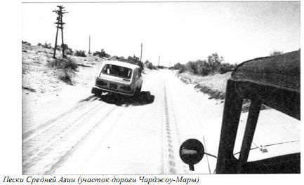
PIC: Sand in Middle Asia. (road Chardzhou - Mary)

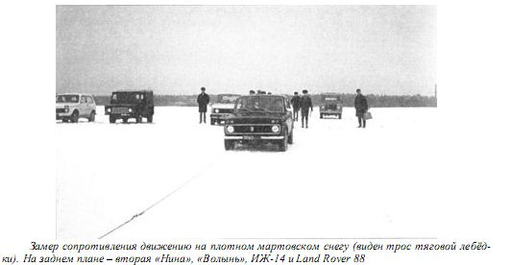
PIC: Gauging of resistance of movement on dense March snow. The cable traction winch is visible. On a background – second Niva, Luaz, Izh-14, Land Rover 88

So, the result of tests was positive. With some nuances. On them worked in 4th and 5th series of the car throughout 75–76 years.
In February, 1976 there was XXV congress of the CPSU, and in a gift to it it was necessary to collect 50 cars. These 50 Cars have been given to operation on the different enterprises of the country. And from them 49 has returned on factory for completions. And as the result — in 1977 has earned production line of 62th the assembly case, and the NIVA has begun win the World.
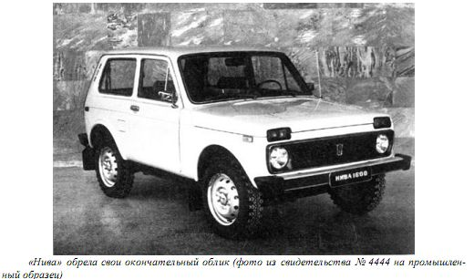
PIC: The NIVA has found the definitive shape. A photo from the certificate №4444 on the industrial sample

