Installing a high-output Alternator

Details About The Project:
-Even with a brand new Niva, the charging system on these little critters has always been ho-hum even at the best of times. I have worked on the alternator and electrical wiring on every single Niva I've driven, with the very best results I've even seen being a charging system that barely puts out 14V with no load (not even headlights) at speed. My latest Niva put out barely 13V at speed with no load, and as soon as I was sitting at a light (with brake lights on) and idling, the system would dwindle down to 10V, sometimes even 9V. When I blew my clutch (and, coincidentally, the wiring for my starter) I decided since I had to take out the alti anyway (to get the starter out + it needed a new fanbelt), I may as well change the system altogether.
-The perfect candidate was suggested to me by a couple goons who have done this to their Niva a long time ago. Check out their site here: Rugrat and Dockers
-The alternator used is a GM alternator rebuilt by Bosch to the tune of 100A. Cost me just shy of 100$CDN but I'll get a 20$CDN core charge back when I bring them a cooked alti.
-Right from the get-go I came upon a fairly big problem. My Niva (95) was one of the Nivas built while they were adaprting Fuel Injection to the new 1.7L engine, but it still has what seems to be a version of the original carb Niva 65A alternator, which just happens to be a bad alternator to boot. Anyways the mounts are totally different from my Niva. Fortunately, having a couple Nivas around, I was able to pillage a set of later model (96+) alternator mounts, which are the right size for the GM alti.
-I still needed to do a couple quick modifications to the mount to make it work with the GM alti. The first thing was to drill out the hole in the mount to the same size as the bolt-hole in the alti casting. This was easily accomplished with a drill press and 3/8 bit.
1.The post with the red plastic is the alternator output source, and is connected directly to the battery. On the far right you can see a bolt which can be used to hold a grounding strap if so desired. The two tabs on top are for the no charge light on the dash and (I think) the other is to control the feild winding.
2.On the left, old and crappy, and on the right, new and sexy. You can see here the difference between the mounts. Don't worry, older Nivas still have 3 bolt holes and can fit the new mount.
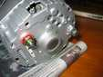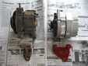
Installation
-To get the alternator physically in, I had to take off the top and bottom mounts, shove the GM alti into the hole, and then wiggle around the alti to bolt up the bottom mount. It's a tough thing to get in there, but surprisingly enough it fits very well once it is in place.
-I could then loosely bolt up the top mount and, using washers as spacers, I then put in a new 3/8"X4.5" SS bolt and adjusted the spacers until the pulleys were lined up. At this point I tightened up the belt and tightened down the adjusting bolt on the top mount and the top mount itself. I had to leave the mount a bit loose during this step, once it is tight, there seems to be interference which does not allow tightening of the belt. Sounds kind of hokey but it works.
-I then did the wiring. I made a new post when I replaced the starter and I had ran 2 fatty 8ga wires with good terminals & protected with shrink tubing. I hooked these up to the post with the red plastic guard. I used dielectric grease on the post because that stuff works miracles.
-I then had to run the wires for the dash light and feild windings. This is where things got tricky. I thought it didnt matter which tab you use for what, but it does. On my first try I ran them upside down and as a result I fried my diode. Fortunately it was under 5yr warranty so I had no trouble getting a new alti. The next time, I used my multimeter to find which post had a circuit and which didnt. one had 40ohm resistance and the other had a lot more. I hooked the 40ohm post to the wire for the dash light, and the other post directly to the battery. Now she works beautifully.
1.Paint your brackets red, as we all know, every part you paint red adds 10HP.
2.Yellow wire is to the battery (+) and brown wire is for the light on the dash. You can also see the two fatties I ran to the battery, fat wires means less resistance and more juice.
3.While I was on the project and since I cooked my starter wiring, I installed a pretty little push button starter on my dash. It's fun.
4.This is the first time even in a Niva I've seen 15V output (well, except when the regulator on one of my Iskras jammed closed and it was making 13V at idle and 17+V at speed.
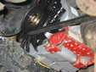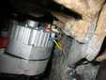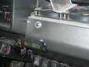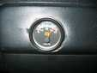

UPDATE!! 01-13-2006
-The most current part number I have for a GM alternator is a rebuilt Champion Unit. CTC P/N 19-4801-8 .
-As far as fan belt size goes there's a few choices. It seems that depending on the particular alternator that you get sometimes sizes can vary. Basically you might have to try a couple ones before you get the right fit. If you are using the stock top bracket from a late model Niva belt selection is very tricky. In order for the belt to stay tight for more than a couple km's you'll need to buy one that is so tight you can't get it on by hand. That's the only way you'll have enough adjustment in the bracket to keep the belt tight for any length of time. You need to wait for a nice hot sunny day to put the belt on or plunk it in some boiling water beforehand to get it really soft so it's easy to get over the pulley. I've found it's easiest to put it on the alternator and crank pulleys first and then use a flat screwdriver to hold a bit of it on the waterpump pulley and get your assistant to turn the crank over with a 1-1/2" wrench on the crank nut until it plops into the groove. Sounds hokey but IT'S THE ONLY WAY TO GET IT TO WORK WELL.
-Fanbelts seem to have a universal numbering system to describe the size. The 5 digit number seems to describe the width and vee angle in the first couple digits and the length in the last couple. The belt I am personally using right now is a 15365 (don't have the CTC P/N on hand). I've also used 15370 (slightly longer, CTC P/N 14-1207-2). I also have a spare 15375 (even longer still, CTC P/N 14-1210-2) but have never used it.
-Once you find the right length of belt for your alternator, buy two more the same size and keep them in the car. Obviously you should also always carry a 13mm wrench, 17mm wrench or preferably socket/ratchet, also either a pair of 14mm or a 9/16" and a 14mm or a pair of 9/16" wrenches (if you are using the 3/8 bolt), 14mm and 9/16 are usually interchangeable unless the nut is rusted. If you can bring a 1-1/2" wrench to turn the crank pulley you will swear about 100 times less when you have to do a belt change on the side of the road. Of course if you're driving a Niva you should already know that you need these tools with you all the time anyways.
1.More pictures below are of the engine I'm currently running in my Silver Niva, taken as I was assembling it in the winter of '05.
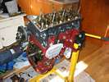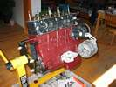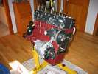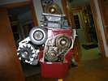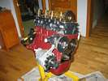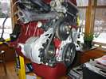
UPDATE #2 01-13-2006
-Below is a picture of a GM 100A 1 wire alternator available from Jeg's High Performance. If you want to get fancy this will bolt right into your Niva same as the alternator shown above. Click the picture to go to the Jeg's Website listing or if the link doesn't work go to www.jegs.com and do a search for part number 555-10100 . Have fun!
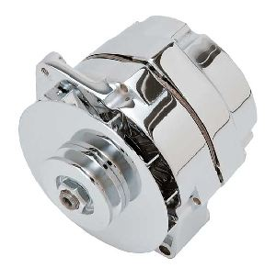

Sean Huffman

_____________________________

1600 Nivas mostly have internally regulated 55-65 Amps, a pillar terminal for the main wires and a 1/4" spade for the charge light feed.

