Home-made sandtraki

Wrote Administrator
10.03.2007
It reached me to completely convey boards with itself. Slippery, wheel on it skids, especially when board into mud, wheel to the side jumps off. Version with lacing of board by rope was tested, but to sense from the rope nevertheless proved to be little. As a result was prepared the sleduyashchaya construction.
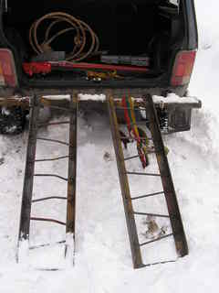
Materials:
Four 50th corners on 1,2 meters (it was done for the field, so as to they would enter into baggage carrier).
6 it is meter steel framework 10 mm.
Production:
On the corners the angles are blunt by Bulgarian, in order not to scratch by chisel edges. Steel framework is cut into pieces of 30 cm (it is obtained 10 armaturin to one track-link). All this welds on to each other. Reinforcement to the corner to weld on compulsorily from two sides, otherwise armaturiny can tear off, since they will be tyuey otgibatsya and seam will work on the fracture, that also happened during the first testing. The second copy wanted to make only pouzhe, so that it vkhodl into the first as matryoshka; therefore armaturiny would make more shortly on 15 mm. but with the welding they would catch at first only the ends of the track-link, and in the welding process from heating of ugoloki it bent out by arc in the middle - as a result they into each other do not enter. Consider deformation immediately, and before the final welding of steel framework at first slightly catch it.
Test:
The first testing passed not entirely successfully, since devaysy it cooked by semiautomat, on top of that, also, in the hurry; therefore welded on reinforcements only from one side. Stress in the garage of katostroficheski does not be sufficient, svarochnik first cooks that no, yes even it is rather bad semiautomat for 5 mm of corner. As a result their part it fell off. Later we already welded them simple svarochnikom. Testing already finished devaysa passed successfully. Wheels excellently are caught for the steel framework, here mainly strongly to not skid on the track-link in order not to poportit' rubber. It left from the snowdrifts practically without digging by shovel. Wheel to the side does not jump off. It is singularly bad to then search for devays in snow in the track, rope with the buoy of chtoli to it to tie? It is possible and narrow ditches to cross, and to the high steep slants to drop in on this devaysu.
Testing they continue. There is no snow already then there is mud and swamp. They drove into the forest to mark points for the orientation soil with places is very saturated by water. Only buksanul and on the belly. Several times was necessary to use track-links. If we lay under preredniye of wheel, then on them machine drops in even into the hill. I.e., dzhechim for the front bumper, into the track under the the front kolesapodkladyvayem track-links, we lower. Machine pritaplivayet track-links and they seemingly suffice into the hill. And here from this position machine quietly is selected without skidding on the track-links. With what rear wheels even they were not unearthed. In the second swamp where we settle for a long time on the track-links machine quietly it left, but as track-links they ended again it sat down itself it sat down itself. By devaysom it is contented. Only of mud certainly on it it will be accumulated. To convey better on the baggage carrier (thus far yet it did not make).
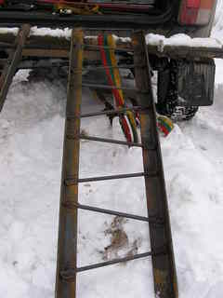
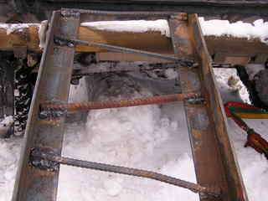
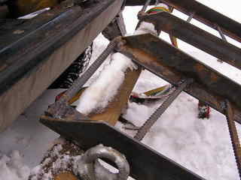
Last renovation (11.05.2007)

