Eliminating the cheat of the oil pressure gauge for 2103 (and 2107).
Text and photo: Miklos Szentirmai
Translation: z.
At the December meeting I got a 2103 oil pressure gauge. (see 2107 at the bottom of page!) I bought a sensor for it, and I assembled the thing on my desk. At the meeting I had heard of low readings of this gauge - while the engine itself was perfect. Therefore I made an experimental test regarding the gauge cheat. I connected the sensor to an air compressor. I got the following readings!
(text is continued below the pics! z.)
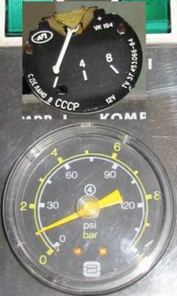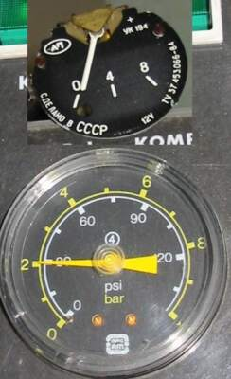
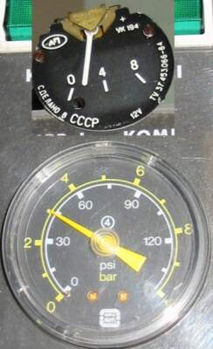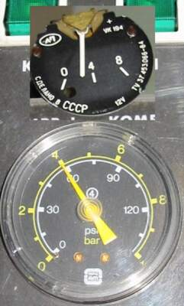
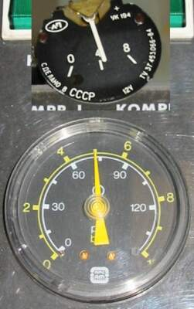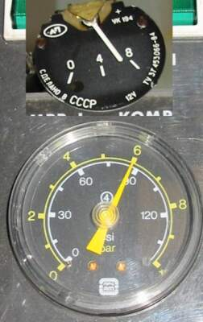
It is obvious that my gauge reads a (much) lower value than the real pressure. It starts to be more accurate at 8bar, but this is not necessary for us. In a Lada accuracy is needed at 3..4bar.
How to solve the problem:
A resistance is needed to be soldered between the gauge earth grounding and the connector of the gauge coil. Originally the coil is connected to the earth point. This has to be removed. You have to connect the coil to the ground via the resistance.
Picture labels translated:
connecting point, with coil lead. Between the lead and point you put the...
...calibrating resistance: 0-100 Ohm
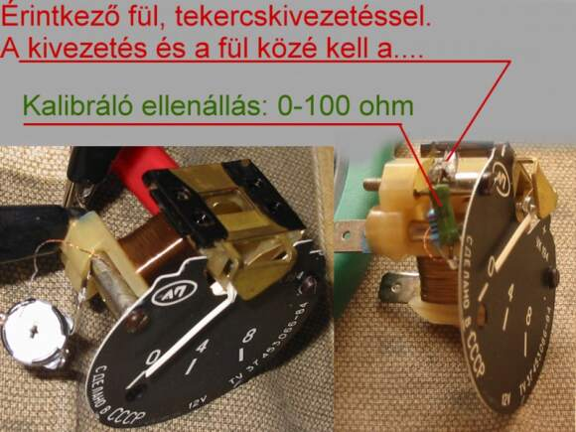
My result is 74 Ohms: I put a potentiometer there and tested results. When both pressures read the same I had my final resistance set. Of course this value may differ from gauge to gauge; the value depends on your luck.
After calibration the readings were as follows:
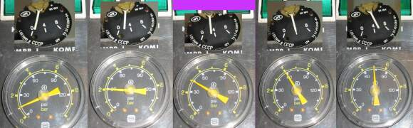
You can see the lower values became accurate while it cheats more above 4Bar.
In a street Lada you don’t have to be afraid of this range.
There is another way for gauge calibration for those who don’t have an air compressor at home :-). I experienced switching on the ignition but not starting the engine the pressure is of course zero (0), but the gauge doesn’t do anything. At this point, adjust (with a temporarily installed potentiometer) the gauge until it reads exactly zero. Now the potentiometer can be replaced with the resistance it represents. Adjusting the gauge this way, the cheat of the gauge will be approximately equal to the width of the pressure meter's finger, at its maximum.

