Fold the Seats into a Bed
Translated (badly) from Russian sorry, but from the pickies you get the idea of how to bend the hinges.

The owners 21- X of "fields", and, as I heard, by "zubilok-khetchey" can be arranged to the lodging for the night with all conveniences, after decomposing the back of rear armchair up to the fifth door. As a result the salon is converted into the bed of Ludovik BY THE XIV to three personas. For this it is necessary to lead a little back from the catchs, then to stretch upward for junction of back and sofa to the formation of the obtuse angle between them with the calculation of that so that the back could push through between the catchs and the upholstering of arches. To further eject back in the side of back and to pack it in the baggage carrier at its own discretion.

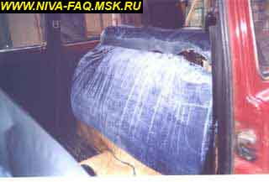 | 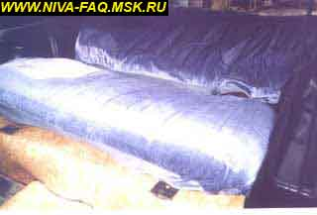
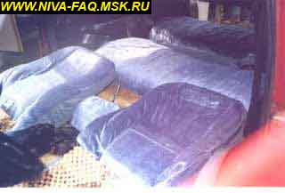 | 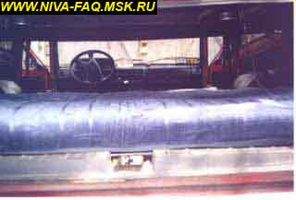
For 213- X OF "FIELDS" such numbers are not passed, apparently, because of a change of constructing the loop between the back and the sofa, as a result of which the seat relative to sofa is not reversed further right angle and back cannot be pushed through where must be. With the transposition of the upper part of the loop, which is attached to the back, on 180° appears the possibility "to turn inside out" to the necessary state. Transposition is produced by means of the L-shaped key to 13, the hammer and the knockout along the diameter of the axis of loop. I do not know as in whom, but in me axes stood from within outside, that not there is conveniently for their extraction. Therefore they drove into outside inward after transposition 4. Still it is necessary to cut out the parts of the plastic cover plate of back, which prevent the new arrangement of loops.

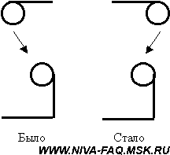 | 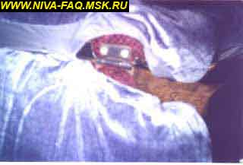
With the dismantling of back, the left lath of catch is abutted against the neck of the tank of omyvatelya of rear glass. Therefore necessary having first bent back to push through left arm under the neck, and then, to lower right. The different version - to leave the back higher than neck, after placing under it anything. Will come out unique pillow - elevated bed-head. The third version - for such Nivovodov as ALER, 4, etc., that use a "correct" spoiler - to generally throw out the tank: -).
The inconveniences of the alteration pointed out above lies in the fact that impossibly will become to add back regular means, since with this change in the loop, back not will be plotted to the sofa. 4 with its increase used regular storing, but with raskladyvanii of sofa as I described never above, IMKHO, baggage hold not is less convenient, since it is possible to sit from behind with the transportation of load (dream Of nivovodov about the cut rear back). Main thing - to convey with itself any horse-cloth for to postelit' to the sofa under the load.
Quiet Don, 10.05.01.

Second method (Alexey73)
The axes of the loops between the pillow and the back are knocked out. Back places into the baggage carrier, the pillow of rear seat raises itself on the loops and moves aside only back, lays under the tail end of the pillow box with the collection of heads, head rests are removed, they place between the seats (in order not to fall through), the back of front seats they are removed back. It is possible to cover with blanket. And preparedly 2 recumbent places with a length of more than 2 it is meter. With the transportation of luggage the back places on the pillow (by upholstering inward) and large baggage carrier is obtained. Without the axes the back normally is held on the catches already yr.
Alexey73, 10.05.01.

Third method (Trophyman)
I will begin from the fact that many, who drive in their machine not only around the city, to the work and to the dacha, for sure thought about the more convenient overnight stay than reclining in the driver seat. For me was in prospect two days to conduct in the scaffolding after the control of its Nivochki on top of that together with the wife, and this forced me to think about the equipping of more convenient lodging for the night.
Approximately one hour it was required to obmozgovyvaniye and embodiment into the life of this idea. Main requirements:
- the back of rear seat must be spread completely;
- rear seat must visually will not change;
- it must remain convenient in the usual position;
- it must be added as before forward for the transport of load.
It was possible to personify all these points into the life.
The schematic of the rear seat of field and hinge of back is given in Fig. 1 and 2.
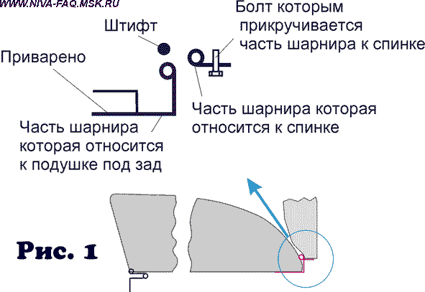
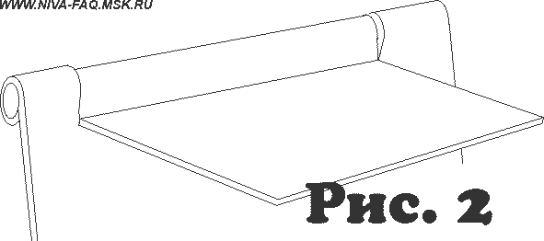
Basic idea consisted in that, in order to, after raising pillow "hearth to priest":))) for the place of bend and after overturning back it is back more than to 180º, to push through it under the catches into the baggage carrier. However, back with the usual fastening simply physically cannot turned to this angle, since with the angle already about 100^{against} the halves of hinge are abutted against each other (the same effect can be seen, for example on the piano hinges and on some door). Somehow 4 this it attempted to depict on Fig. 2. Furthermore, even if hinge could be turned 360º, the bolts fastening back nevertheless rest and do not give it to decompose. Were such my reasonings.
I propose to solve this problem thus:
1. we remove rear seat.
2. we unscrew back and put aside it to the side.
3. half of the hinge, which relates to the "pillow hearth to priest", is the plate bent by letter "G", welded to the frame of seat, with two lobes bent into the tubes: in them the pin (see Fig. 1 and 4) is put.
By the gas key of the suitable size we press this very "tube- lobe". To stop up it is possible into the vises or by another convenient method. Then we unbend tube as shown in Fig. 3 and 4 outside - from the seat, the line of bend must be the continuation of the cavity of that formed by these two by "tubes by lobes" (see Fig. 4).
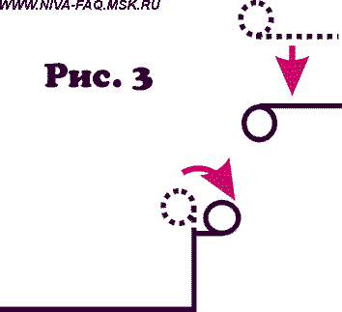 | 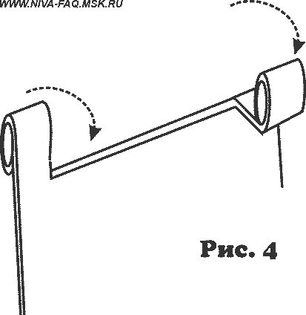
4. We knock out pin and turn the half of the hinge of the back (see Fig. 3) vice versa.
5. we assemble hinge conversely.
6. we screw on back.
7. we place conversely seat.
8. we attempt to decompose the seat (see above).
If back did not turn itself to sufficient in order to climb through at catches, angle, it is necessary to press on it - it itself will complete the remained work, after bending out welded-on half of hinge to the necessary angle.
I do not know, as on other models, but on the 2ye-oy field seat can have two positions due to the hinge of that attaching it to the body - usual (with the normal position) and barely moved aside back (for the displacement with the transport of load). After unrolling back into the baggage carrier, we transfer seat into the second position. This gives convenient ledge, where the backs of the front seats (preliminarily necessary to push them maximally to forward and remove head rests) lie down well. Furthermore, this position of rear seat ensures the flatter surface of the received bed.
Again I will be repeated, that this procedure is tested only to 21213 and on other models can require some changes. Furthermore, it can seem that the nerodnye front seats do not get in in the decomposed form.
My observations:
Junk from the baggage carrier (if it, certainly, is not oppressed under the string) it is possible and not to take out - back will fulfill the role of pillow. Some household goods can be from the baggage carrier shifted under the backs of front seats.
To sleep is simply healthy:))
I will be rad, if it proved to be to someone useful.
On the whole, I desire to you, lady and gentlemen, pleasant dreams:))).
ASK, 02.10.01.
Fourth method (Ekzarkh)
I selected the method, similar to the second method. Simply it unscrewed the bolts, which attach the back of seat to the loops. Came out four versions of the transformation of the salon:
- usual all-passenger layout,
- the usual cargo version (seat and back vertically after the rear seats),
- back on the seat (on the left photo),
- sleeping version (on by the right of photo).
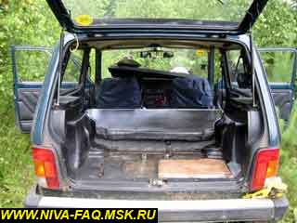 | 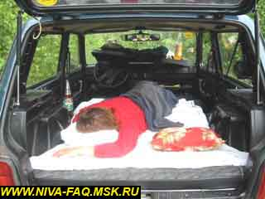
Furthermore, back can be in seconds generally removed from the salon in order to free the place occupied by it, or in order to make the improvised seat on the forest stand. More than year I use this method, in this time in the usual position the back is held not worse than screwed on, but in the decomposed position luxurious sleeping place is created. Many times we with the wife passed the night in the field during the distant journeys, and we find that this is more comfortable than in the tent.
Ekzarkh, 05.05.03.

