Niva Tow Hooks

Cloggy’s Tow Hooks

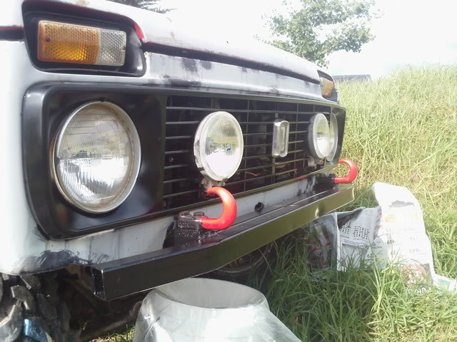

After owning the Niva for more than ten years now it is probably not a moment to soon to fit some decent tow hooks. I have been contemplating about how to do this for quite a while because the Niva doesn't have a separate chassis like most other 4 wheel drive vehicles. Lots of people gave their opinion about which way they reckoned it should be done, none of these ideas I really liked. The following is what I have come up with.
I started by removing the front bumper and the round tubes which hold the bumper to the vehicle. Once these were removed from the car a quick check of the inside chassis measurement with a snap guage confirmed that a piece of 50x50mm box section steel would fit snugly inside the chassis rails.
The next step was to reshape the round holes where the tubes pass through the lower valence panel into something resembling a square hole to suit the new tubes. This was quickly followed by pushing a piece of square tube up the chassis rail to confirm that it was indeed going to work and to work out how long to cut the new chassis extensions so the tow hooks would fit as well as the original bumper. The square tube can't be pushed as far up the chassis rail as the original round tubes were because the mounts for the round tube are in the way. So I decided to utilise these mounts as well which meant I had to weld a piece of the round tube on the back of the square tube.
Once I had worked out all this and got the length I wanted, I decided to weld in a cross-brace between the two bit of square box sticking out the chassis now. Reason for this is that I wasn't too keen on just relying on the lower valence panel for strength. When recovering a stuck vehicle more often than not the direction of pulling is not directly forward or backwards but requires pulling from or to one side. The sideways stresses places on the chassis at these times can be immense. The cross-brace will transfer most of this load equally across both chassis rails.
Because I wanted to retain the front bumper in more or less the stock location I had to space the tow hooks up a little. In order to do this I welded a couple of pads on this new frame which was beginning to take shape on front of the car. Next to be attached were the bumper mounts. These were simply welded to the frame. In order for the bumper to remain in its stock position I had to cut out two U shapes to fit around the tow hooks. I realise this weakens the outside corners of the bumpers substantially. If this proves to be a problem when off-roading then I will add some extensions outwards from the frame to
At the rear of the car all I have done for the moment is remove the tow-ball from the tongue and fitted a rated bowshackle (10000lbs.) through the hole.

I’ve managed to lose the images that go with this piece; please let me know if you have a copy.

Errol Johns’ Tow Hooks

I upgraded the bumpers including adding some decent tow points, along the lines of Cloggy by replacing the round tubes with box section, however instead of mucking using 50x50 box and welding round tube to the end and having to cut the body work, I found a piece of 40x40 box fits perfectly into the original round holes, saved a lot of hassle.

