Arch Rolling
I've looked at several peoples' re-sized wheel arches. Everyone cut away the metal they did not want and then fabricated new metal back in to make it look neat again. I went a different route. I turned the flared section of the wheel arches to the inside and up. I did this with nothing more than a hammer, tin snips, pop rivets, a drill, and an assortment of sockets and wrenches.
The flared section of the wheel arches has been stamped out in a huge hydraulic press. This press basically stretched the metal so that it conforms to a shape. Metal is malleable in that it will stretch. It takes a lot of work to make it stretch by hand, however.

Fender Liners
The first thing I did was remove the fender liner and cut away the the outer section that dropped down with the flared part of the wheel arches. You can see from the picture just how much it drops. This is approximately how much additional clearance I will realize from this project. Removing the liner revealed a huge factory "hole" which would now be exposed to mud/dirt/salt/snow/etc. and fill up. So, I cut a piece of tin for each side and pop riveted it over these "holes" to close them up. Then, I undercoated it all.

Click on thumbnails for a larger image.
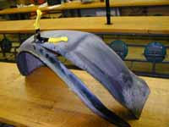
Cutting Fender Liner

Wheel Arches
The flared section now needed to be stretched back and around to the inside. Basically, you need a lot of patients and a good arm to swing a hammer with. Work evenly around the whole arch to avoid/reduce any kinking of the metal. It will take many blows with the hammer before you actually see anything happen. Keep on tapping! It took me about 5 hours of hammering to turn all four of my flared arched to the inside and up. Then, I painted the arches black where the paint had chipped off from hammering.
Remember, slow and steady wins the race. Too much heavy hammering might get the job done quicker, but you will have far more kinks and "dents" when you're done. As it is, I still have some; however, I'm not too worried as you only notice them if you're up close and "looking."

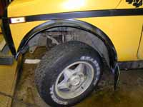
Re-formed Front Wheel Arch
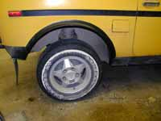
Re-formed Rear Wheel Arch

Tires
Tires were next on my list of "things to do." We have had a couple of snowfalls and I have been sliding around with the old tires on my Niva. I did a lot of research on the various tires that would fit. The best tire that I could find for my needs was the Yokohama Super Steel 742S. This is a 29.8" diameter tire with a very narrow tread. I found many 29" and 30" tires; unfortunately, they all had a wider tread than I wanted. For most applications, a narrow tire is far superior to a wide one.
I took the old wheel weights off and then took the old tires off. I cleaned the inside of my rims and installed new valve stems. Then I put the new tires on. Finally, I balanced them and put them back on my car.
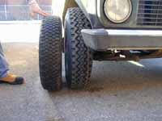
Old VS New
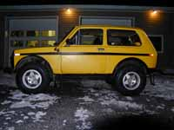
29.8" Yokahama Tires
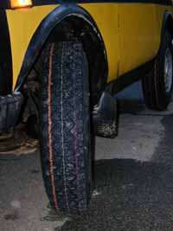
29.8" Yokahama Tires

HOW TO DO IT
- Step one: cut fender liners to size
- Step two: reform (hammer) flared wheel arches.
- Step three: paint arches.
- Step four: balance and install new tires.

JOB TIME
Reforming the wheel arches took me about 5 hours.
Balancing and installing new tires took about 20 minutes.

